Waniyetu Wowapi (winter count)
Lesson: Winter Count Dyes

(Demos)

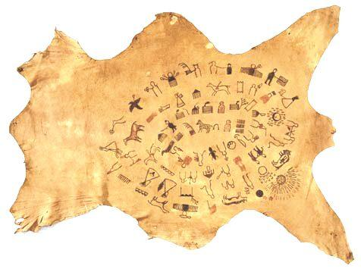
Lesson Plan: Winter Count Dyes
Background: A winter count is a pictographic record of historical/memorable events for a tiospaye (community). The pictures, which were used as mnemonic devices, are arranged in chronological order. Originally, the memorable events were recorded on rock (many paintings found on cave walls, canyons and mountains throughout the Great Plains), on buffalo hide, deer hide, cow hide, and then ledger paper and muslin (cotton fabric).
The Lone Dog Winter Count
Smithsonian Institution
The dyes used to record the images also changed over the years. Berries, clay, plants, roots, and buffalo gall (liver bile), blood and stomach contents were a few of the materials used to draw the images. During today’s investigation we will test the quality of several natural dyes/pigments by checking for clarity and deepness.

Materials:
    - Review: Waniyetu Wowapi (winter count) Blog – Background information, videos, audio interviews, and more!
    - Variety of fruits/berries (the students should be reminded that they should never eat anything during an experiment)
      - Grapes (dark)
      - Cherries
      - Strawberries
      - Mulberries
      - Blueberries
      - Etc.
    - Glass/ceramic bowls (enough for each fruit/berry)
    - Utensils (crush the fruit)
    - White cotton cloth (old sheet cut into 4”X4” swatches)
    - Mild liquid dishwashing detergent
    - Clock with second hand or stopwatch
    - Cotton swabs (Q-Tips) or brush
    - Chart
    - Paper towels
    - Aprons/gloves (optional)
Procedure:
During this activity the students will learn about natural dyes/pigments used to draw images on winter counts. The students will crush fruits and berries and then they will use the juice/dyes produced to paint cotton swatches.
- Setup/Process
- Collect the materials.

(Demos)

Waniyetu Wowapi (winter count)
(Lesson: Winter Count Dyes – page 2)

(Demos)

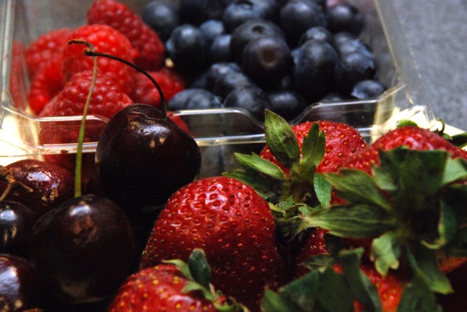
- Crush the fruits/berries in separate bowls (remove the large pieces, leaving the juice).
- Cut an old white sheet into 4”X4” cotton swatches.
- Use a brush or cotton swab to paint a 1-inch diameter circle on the cloth. Each dye should have a separate cotton swatch.
- Wait 10 minutes and then check for clarity (sharpness – defined edge) and deepness (range from dark to light).
- Using the chart, mark clarity and deepness for each sample. Use a scale of 1-10, 10 being the sharpest and deepest.
- Wash each sample in a mild mixture of water and dishwashing detergent. Wash each sample for 10-15 seconds. The scrubbing force, duration and action for all the samples should be the same.
- Place the swatches on paper towels to dry or hang dry. Let samples dry for 5-10 minutes.
- Using the chart, mark clarity and deepness for each sample. Use a scale of 1-10, 10 being the sharpest and deepest.

What to expect: The students should realize that natural dyes work very well. Many of the fruits/berries tested will remain in the cloth for extended periods of time. The students may have experienced staining their clothing while eating fruits/berries. The students should also conclude that winter count images are durable, but they can be prone to fading/breakdown over time due to environmental influences. Winter counts need to be protected to preserve clarity and deepness.
Extension: Each student could select an additional item like ketchup, mustard, or chocolate syrup to test. Also, the natural dyes could be compared to compounds like permanent marker or tee-shirt paint.
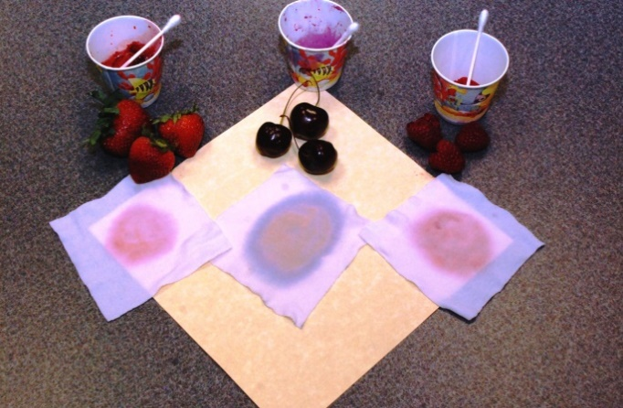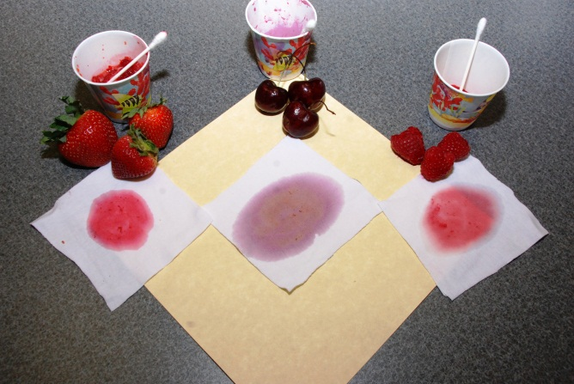
Prewashed
Samples
Washed
Samples
Oceti Sakowin Essential Understandings and Standards

(Demos)

(Demos)

