Waniyetu Wowapi (winter count)
Lesson: Class Winter Count

(Demos)

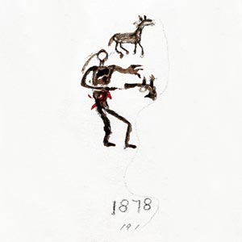
Lesson: Class Winter Count

Background: A winter count is a pictographic record of historical/memorable events for a tiospaye (community). The pictures, which were used as mnemonic devices, are arranged in chronological order. Originally, the memorable events were recorded on rock (many paintings found on cave walls, canyons and mountains throughout the Great Plains), on buffalo hide, deer hide, cow hide, and then ledger paper and muslin (cotton fabric).
Each tiospaye designated a winter count keeper. The keeper (traditionally a man) of the winter count was the historian for the community. Elders would gather and consult with the keeper to select the most important event of the year (first snow to first snow). The keeper would then draw an image on the winter count to represent the event. The images on the winter count were used as a reminder/aid to help the keeper remember the events. The keeper (oral historian) could then explain the events in detail.
Winter Count: Battiste Good (1877 – 1878)
Crazy Horse came to make peace and was killed with his hands stretched out. Image: Smithsonian Institution

Materials:
    - Review: Waniyetu Wowapi (winter count) Blog – Background information, videos, audio interviews, and more!
    - Notes
Procedure:

During this lesson the students will create their own winter count image by identifying an important event that occurred in their lives during the school year. The students will present their winter count image to the class. Parents, guardians, and elders will be invited to attend the presentations. The presentation attendees and the students will choose/identify a Winter Count Keeper for the Class Winter Count. The chosen Keeper will record their image on the Class Winter Count.

- Setup/Process
- Each student will identify an important event that occurred, within the school year, in their life, at school or in the community. (Examples: State BB Championship, death of someone from the community, new school building, etc.)
- The students will use paper or cloth to create their winter count image. (8.5”X11” – easy to scan)

(Demos)

Oceti Sakowin Essential Understandings and Standards

Waniyetu Wowapi (winter count)
Lesson : Class Winter Count

(Demos)

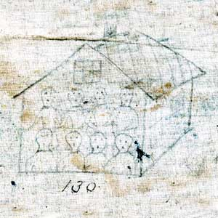
- Displaying the images for the presentations:
  - Scan/photograph the images
  - Place all the images in one PowerPoint Presentation.
- Larger poster boards could be used to make the original drawings if a PowerPoint program is not available for the presentations.
- Invite parents, guardians, elders, etc. to attend the presentations.
- Have each student explain their image when it is displayed on the PowerPoint presentation. They should explain why they chose the event and how the image will help them remember the event in the future.
Winter Count: Rosebud (1880 – 1881)
Children sent to school.
Image: Smithsonian Institution
- The attendees should make notes, of each winter count image, so they will be able to vote for their favorite image.
- Each attendee should cast an anonymous vote for their favorite winter count image. Collect and tally the votes. (Traditional – not anonymous)
- The student with the most votes will become the Winter Count Keeper for the year. They will record their image on a large Class Winter Count which should be displayed in a prominent location. Make a Class Winter Count out of a sheet or a large piece of paper. Lone Dog’s Winter Count is shown below for design ideas.
- A new Keeper is chosen each year to add an image to the Class Winter Count.

What to expect: The students should realize that time and effort is taken to create an image that will spark the memory of the Keeper because the Keeper is responsible for providing an oral account of the images drawn. The Keeper of the winter count incorporates their personal history, artistic talent and visual interpretation of the event into their image. The attendees are the elders who help select/identify the most important event for the year.

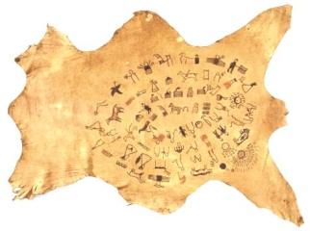

Oceti Sakowin Essential Understandings and Standards

(Demos)

The Lone Dogs Winter Count
Image: Smithsonian Institution

(Demos)

