Waniyetu Wowapi (winter count)
Lesson: The “Keeper” of the Count

(Demos)

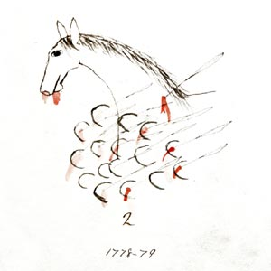
Lesson Plan: The “Keeper” of the Count

Background: A winter count is a pictographic record of historical/memorable events for a tiospaye (community). The pictures, which were used as mnemonic devices, are arranged in chronological order. Originally, the memorable events were recorded on rock (many paintings found on cave walls, canyons and mountains throughout the Great Plains), on buffalo hide, deer hide, cow hide, and then ledger paper and muslin (cotton fabric).

Winter Count: Cloud Shield (1778 – 1779)
Many of their horses were killed. Smithsonian Institution
Each tiospaye designated a winter count keeper. The keeper (traditionally a man) of the winter count was the historian for the community. Elders would gather and consult with the keeper to select the most important event of the year (first snow to first snow). The keeper would then draw an image on the winter count to represent the event. The images on the winter count were used as a reminder/aid to help the keeper remember the events. The keeper (oral historian) could then explain the events in detail.

Materials:
    - Review: Waniyetu Wowapi (winter count) Blog – Background information, videos, audio interviews, and more!
Note: Blank event cards included for current
    - The Keeper: Event Game (Event Cards/ Event Cards List)
Procedure:
During this lesson the students will learn about the keeper of the winter count by completing the activity below. The students will compete in a game by drawing images of events.

- Setup/Process
- Divide the class into groups of 4-5 students.
- One student from each group should go to the whiteboard. Depending on board size, only 2-3 students may be able to draw at once. Rotate through groups to accommodate board size.
- The students are the “keepers” of the winter count. Select an event card, see step 7. The students selected to draw the event should look at the card. The students should draw a representation of the event selected.
- The keepers have 1-2 minutes to draw the image.
- At the end of the time period – the facilitator will go to each group and pick up one answer, written on a piece of paper, from each group. Do not allow students to yell the answers, because it is impossible to assess which group said the answer first.

(Demos)

Oceti Sakowin Essential Understandings and Standards

Waniyetu Wowapi (winter count)
Lesson: The “Keeper” of the Count

(Demos)

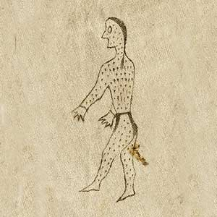
- All the groups with the correct answer will be given a point.
- There are 75 events (for years 2000-2020) included on the following document. (Event Cards – the events were randomly selected)
  - The following list can be printed and given to the groups if they need assistance. (Event Cards List)
  - Make additional event cards for current events. (Also, local - the winning of a tournament, the death of a local elder, etc.)
Winter Count: Long Soldier (1837 – 1838)
Small pox year.
Smithsonian Institution
- Continue selecting cards and rotating through all the students so everyone has a chance to be the keeper.

What to expect: The students should realize that the images drawn on traditional winter counts are not drawn in a hurry like in the game. Time and effort are taken to create an image that will spark the memory of the keeper because the keeper is responsible for providing an oral account of the images drawn. The game should reinforce the fact that the keeper of the winter count will incorporate their personal history, artistic talent, and visual interpretation of the event into each image. This should be apparent by the variety of images drawn for the same event and how many of the students will not be able to identify the event drawn.

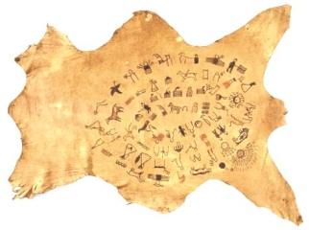
Oceti Sakowin Essential Understandings and Standards

(Demos)
The Lone Dogs Winter Count
Smithsonian Institution

(Demos)

