Waniyetu Wowapi (winter count)
Winter Counts (a closer look)

(Demos)

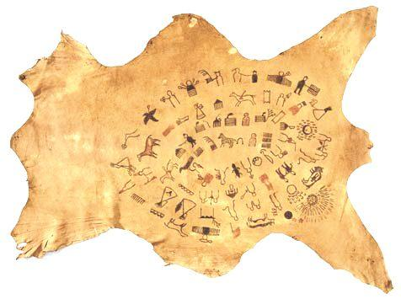
Lesson Plan: Winter Counts (a closer look)
Background: A winter count is a pictographic record of historical/memorable events for a tiospaye (community). The pictures, which were used as mnemonic devices, are arranged in chronological order. Originally, the memorable events were recorded on rock (many paintings found on cave walls, canyons and mountains throughout the Great Plains), on buffalo hide, deer hide, cow hide, and then ledger paper and muslin (cotton fabric).
The Lone Dog Winter Count
Smithsonian Institution
Each tiospaye designated a winter count keeper. The keeper (traditionally a man) of the winter count was the historian for the community. Elders would gather and consult with the keeper to select the most important event of the year (first snow to first snow). The keeper would then draw an image on the winter count to represent the event. The images on the winter count were used as a reminder/aid to help the keeper remember the events. The keeper (oral historian) could then explain the events in detail. (more)

Materials:
    - Review: Waniyetu Wowapi (winter count) Blog – Background information, videos, audio interviews, and more!
    - Interactive Presentations
      - PowerPoint Presentation I
      - PowerPoint Presentation II
Procedure:
During this lesson the students will learn about the images drawn on winter counts by completing the activity below. During the activity the students will compare their own pictorial representation of an event with the original keeper of the winter count.
- Setup/Process
- Open the first PowerPoint presentation - Winter Counts (a closer look) I
Advance through the sides slowly for the PowerPoint to work properly.
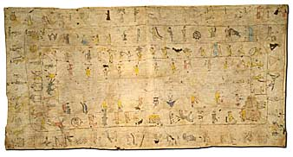
- The students will view textual representations of winter count images and the “Collector’s Notes” for each image.
- The students are the “keeper(s)” of the winter count. Have the students draw their representation of the event chosen by the elders.
- Option: Have 2-4 students draw their representations on the board (rotate through all the students)
The Rosebud Winter Count
Smithsonian Institution
- PowerPoint - Advance to the original image created by the keeper.
- Compare the keeper’s representation with the student drawings.

(Demos)

Oceti Sakowin Essential Understandings and Standards

Waniyetu Wowapi (winter count)
(continue – page 2)

(Demos)

- Continue advancing through the slides. (PowerPoint II - Each with 10 images)

What to expect: The students should realize that the keeper of the winter count is also a historian for the tiospaye (community). The keeper is responsible for providing an oral account of the images drawn. The images should be drawn to help spark the memory of the keeper.
The students should also realize that the keeper experienced the event, which would make recalling the memory much easier. It would be interesting to return (after a few weeks) to some of the images drawn by the students to see if they can recall the textual representations and Collector’s Notes of the events.
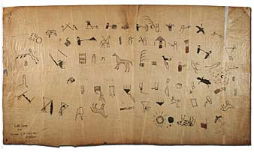

(Demos)

The Swan Winter Count
Smithsonian Institution

Oceti Sakowin Essential Understandings and Standards

(Demos)

