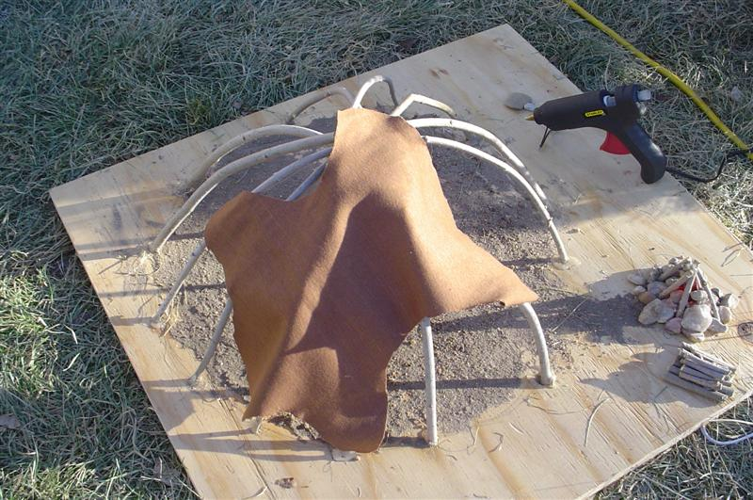
Sweat Lodge Model
A Inipi is a traditional Native American purification ceremony. In the Rosebud Reservation: Domestic Violence segment, Verna Mato Estima commented, “A lot of times women come to the shelter with a lot of mixed emotions and hurt feelings and broken spirits, and so, therefore, a sweat lodge is good.” She continues, "It's good for them to sweat so that they can pray and heal themselves and you know find that refuge within themselves".

Activity:

- Materials Used in the Example Model (possible family project):
  - Plywood 2'x2'x ¾"
  - 7-10 flexible branches (approximately 2'-3' in length – cut to fit)
  - Hedge trimmers/small saw
  - Drill to make holes in plywood for branches
  - Glue to secure the branches (hot glue used in example)
  - Brown cloth – cut in the shape of buffalo skin (approximately 1 yard)
  - Dirt for floor/cut grass for the area surrounding lodge (used Elmer's Glue to secure to plywood)
  - Small rocks represent the heated stones that are carried from the fire into the sweat lodge to provide the heat
  - Small orange Christmas light (fire) / small sticks and rocks
  - Access to a computer to make “Inipi Letter”
  - Sealant (Example: Mod Podge)

- Introduce the activity by learning about sweat lodges.
  - The Akta Lakota Museum and Cultural Center at St. Joseph’s Indian School describes the sweat lodge at the following site. (Inipi - The Rite of Purification)

  - The following video describes a traditional Lakota Sweat. (Live and Remember)

Process:

- A photo album of an example lodge can be accessed by clicking on the following link. (Sweat Lodge Photos)

- The example sweat lodge model was constructed on a 2'x2' piece of plywood. Seven branches were used for the main support of the lodge, they were cut from a flexible bush. Fourteen holes were drilled into the plywood. The diameter of each hole was a little larger than the diameter of the branches; hot glue was used to secure the branches into the holes. Elmer's glue was spread on the plywood and then covered with dirt for the floor. Cut grass was used for the area outside of the lodge. The lodge was covered with small pieces of brown cloth cut into the shape of buffalo hides; hot glue was used to attach the small hides. The fire pit used to heat the stones was made by gluing small rocks and sticks together. An orange Christmas light was inserted through a hole drilled in the center of the fire pit.

- Each student should make an " Inipi Letter." The Inipi Letter will include a list of 3-5 difficulties Native Americans have experienced since their first encounter with the white explorers. An example would be the suppression of the Native American language. This can be a simple listing or more of an in-depth research activity. The Sweat Letter should also include 3-5 difficulties the students are experiencing. An example may include a car accident or a death of a grandparent. The Sweat Letter should be placed in the sweat lodge.

- The Inipi cleans the mind, body, and spirit.

Contact EdServices@sdpb.org for
more information about SDPB’s educational resources

