1.Title / Content Area: | Hidden Stories at Twin Lakes | 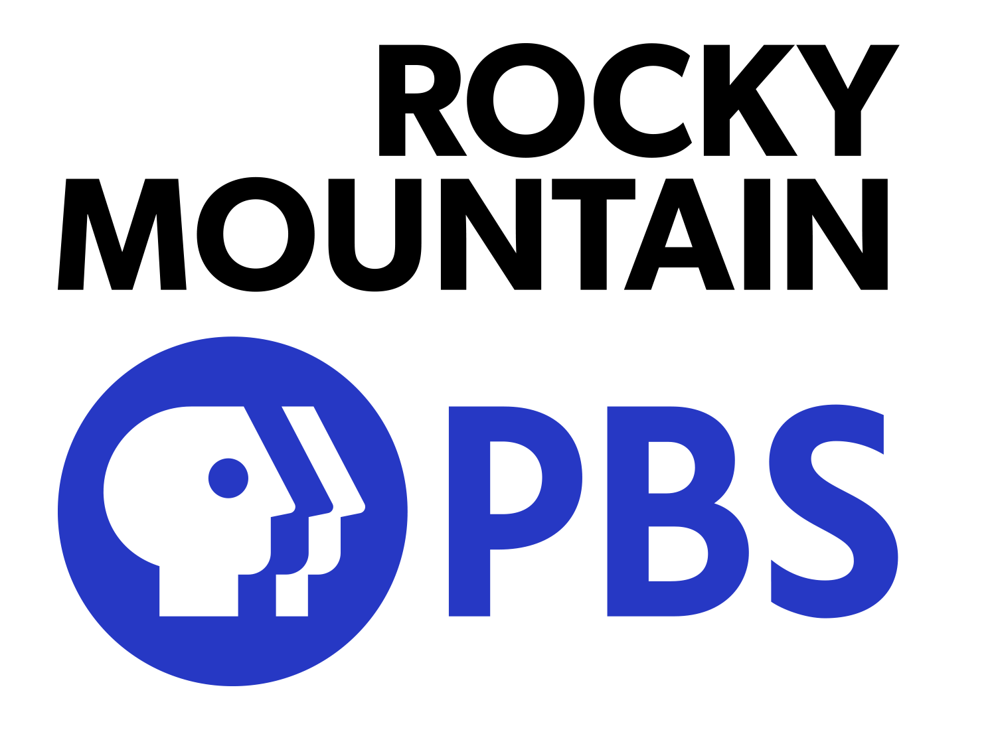  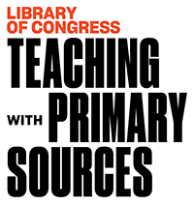
2. Historic Site: | Twin Lakes Archaeology Sites and Mining Communities Near Leadville
3. Episode: | Twin Lakes
4. Developed by:
5. Grade Level and Standards: | Grade Level: 6th - HS  Standards: Colorado Social Studies Standards 1-4  Prepared Graduate Competencies:  Content in this Document Based Question ( DBQ ) link to Prepared Graduate Competencies in the Colorado Academic Standards  6th: PGC 1-5, 7, 8  7th: PGC 1-5, 7  8th: PGC 1-5, 7  HS: PGC 1-5, 7, 8
6. Assessment Question: | How do businesses play a role in how a city and region develops over time?
7. Contextual Paragraph | The area adjacent to Leadville and Twin lakes is filled with archaeological and historic resources, many which are hidden from the majority of the public which visit the region.  Prospectors founded the first village here, Dayton ( now known as Hidden Lakes ), in the 1860s. After a bust in mining, the silver rush brought the area back to life and Dayton was named to Twin Lakes. In 1885 a guide to Colorado named it “..the most charming summer resort in Colorado.” It had 3 hotels, several saloons and many log cabins. There was also mining done in the area and Twin Lakes was a transportation hub between Leadville and Aspen making this region a cornerstone area for tourism, trade, mining, and settlement.  Many recreation users know of the resources and have seen them in the backcountry ( Like Hidden Lakes ) but it is critical to leave them intact. Beyond learning about some of the historic resources in the region, this lesson also includes a reference to the national outdoor ethics program called Leave No Trace.
8. Connection to Historic Preservation | Archaeology plays a critical role in Colorado and our nation and the region surrounding Twin Lakes is no different. It is critical to Leave No Trace near found archaeology in Colorado and our country in general. Ongoing work to survey historic and archaeology resources is supported by the Office of Archaeology and Historic Preservation at History Colorado and records are maintained in the COMPASS database.

Document Based Question (DBQ)
Hidden Lakes Historic District | GUIDING QUESTIONS:  - How do the original homes and buildings that are still standing in Hidden Lakes help to tell the story of the past?  - Hidden Lakes is located at the intersection of Highway 24 and Colorado 82. What is the name of this intersection?  - Why would a town be built on this site in 1890?  - What items would be used and traded in a town such as this?  - How have the buildings been repurposed and preserved?  - Why or why not is it important to preserve these buildings?
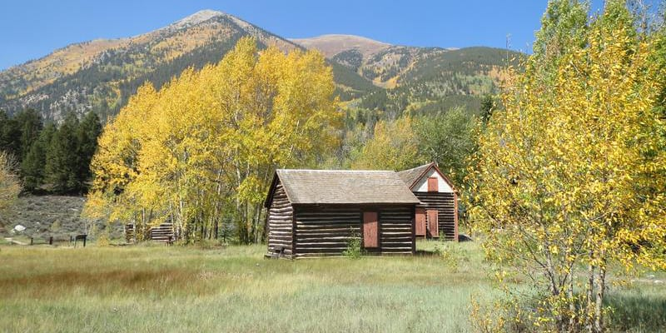

https://www.uncovercolorado.com/ghost-towns/twin-lakes/

Inter-Laken Hotel Twin Lakes | GUIDING QUESTIONS  - Why would a hotel such as this attract people to the Twin Lakes region?  - Why would it be important to tell the story of this place to people who visit Twin Lakes today?  - How did this hotel contribute to increasing the amount of people in the area over time?
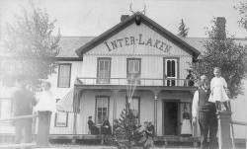
.https://digital.denverlibrary.org/digital/collection/p15330coll21/id/10382/rec/1

Assessment Question
How do businesses play a role in how a city and region develops over time?
Response

