1.Title / Content Area: | Leadville Irish Miners
2. Historic Site: | Evergreen Cemetery, Derry Mining Camp SIte
3. Episode: | Irish of Leadville
4. Developed by:
5. Grade Level and Standards: | Grade Level: 6th - HS  Standards: Colorado Social Studies Standards 1-4  Prepared Graduate Competencies:  Content in this Document Based Question ( DBQ ) link to Prepared Graduate Competencies in the Colorado Academic Standards  6th: PGC 1-5, 7, 8  7th: PGC 1-5, 7  8th: PGC 1-5, 7  HS: PGC 1-5, 7, 8
6. Assessment Question: | How can examining the history that exists within a cemetery tell us about the people who once lived and worked in Colorado whose stories have long been silenced?
7. Contextual Paragraph

8. Connection to Historic Preservation | The Derry Mining Camp was listed in the National Register in 2000, and has contributing buildings on the site that reflect the nature of mining during the time period of the largest amount of burials in the Evergreen Cemetery between 1880 and 1930 and the Evergreen Cemetery is not currently listed. More information can be found on the Derry Mining Camp National Register Nomination (

Document Based Question (DBQ)
Document Set
Evergreen Cemetery Secondary Source Historic Narrative | GUIDING QUESTIONS:
https://lakecountypubliclibrary.org/ld.php?content_id=41034642

Derry Mining Camp SIte | GUIDING QUESTIONS  - Examine the drawings located in the National Register Nomination and linked here. How do the drawings tell the reader that this camp was a larger operation than most in Leadville?  - A National Register Nomination helps the reader to understand why a location is important. This is also called its significance. What did historians determine the significance to be for this site?
.

Irish Miners Memorial | GUIDING QUESTIONS:  - Analyze the elements of the Irish MIners Memorial. What are some of the things you see in the Bronze and stone memorial?  - Why do you suppose these elements were included in the design of the memorial?  - Why would someone want to place a memorial in a cemetery instead of a location in town where it may be seen by more of the public?
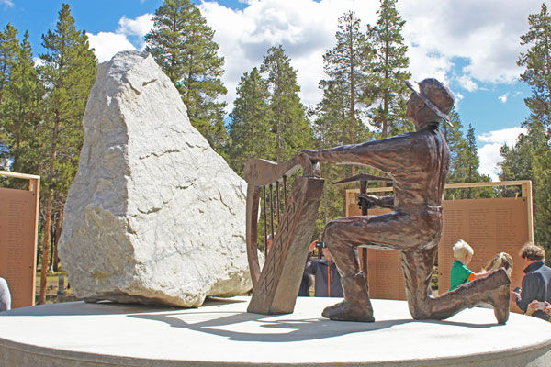

Dedication of the Irish MIners Memorial and Background from the Colorado Sun | GUIDING QUESTIONS:
https://coloradosun.com/2022/10/30/leadville-cemetery-irish-history /

Assessment Question
How can examining the history that exists within a cemetery tell us about the people who once lived and worked in Colorado whose stories have long been silenced?
Response

