1.Title / Content Area: | Women of the Santa Fe Trail
2. Historic Site: | Santa Fe Trail
3. Episode: | Women of the Santa Fe Trail
4. Developed by:
5. Grade Level and Standards: | Grade Level: 6th - HS  Standards: Colorado Social Studies Standards 1-4  Prepared Graduate Competencies:  Content in this Document Based Question ( DBQ ) link to Prepared Graduate Competencies in the Colorado Academic Standards  6th: PGC 1-5, 7, 8  7th: PGC 1-5, 7  8th: PGC 1-5, 7  HS: PGC 1-5, 7, 8
6. Assessment Question: | How did women contribute to the ongoing success of the Santa Fe Trail and the advancement of women’s rights in the United States?
7. Contextual Paragraph | “ The Santa Fe Trail was primarily a commercial and military road mostly used by male traders, but it also served a smaller role as an emigrant route for individuals traveling in both directions between the United States and Mexico. The trail brought many individuals west in the hope of securing a better life for themselves and their families. As a result, several women contributed to travel over the trail. Despite their small numbers, women clearly played a greater role than that attributed to them by early 20th-century historian Frederick Jackson Turner in 1893, when he wrote that women were “invisible, few in number and not important to the process of taming a wilderness.”  Among the Pueblos’ agricultural peoples, women built and owned the houses, cared for the children, prepared and gathered food, produced pottery and cooking utensils, and made clothes. Among the semi-nomadic peoples, women were responsible for garden plots, some food gathering, food preparation, and making clothes; Comanche, Kiowa, Apache, and Cheyenne women of the Plains were responsible for the domestic arrangement of the camps, in addition to food preparation and clothes-making. American Indian and Mexican women not only lived along the Santa Fe Trail, but they also traveled on it and, in some instances, married American traders and trappers who operated on the trail. African-American women served as cooks and personal maids for some travelers. “  The women highlighted in this lesson provided valuable service to their families and the communities on the Santa Fe Trail and made a difference on the rights of all women in the United States. As we look to provide a more inclusive history of our state and country these stories help all of us to understand how people who aren’t normally recognized in a standard textbook.
8. Connection to Historic Preservation | The historic sites located along the Santa Fe Trail played a major role in the success of trading on the trail and also the settlement that occurred in the Southeast region of Colorado. Several of the sites which have contributed to settlement and growth in the region are now registered landmarks and include Boggsville and Bent’s Old Fort as well as Fort Union in New Mexico. Bent’s Old Fort ( A reconstruction of the original fort ) was listed in the National Register of Historic Places in 1985 (Nomination Link) The "National Register of Historic Places Multiple Property Nomination Form: Historic Resources of the Santa Fe Trail, 1821–1880" was written by scholars and placed the Santa Fe Trail in the National Register in 1993. Fort Union was added to the National Register in 1978 as a National Monument (Nomination Link) and Boggsville National Historic Site was added to the National Register in 1986.

Document Based Question (DBQ)
Document Set
Julia Archibald Holmes : Reading from the National Park Service | GUIDING QUESTIONS:  - Why did Julia come west to both explore the region and settle it? List several reasons which brought west and also took her on the the Santa Fe Trail.  - How was Julia active in abolitionist work in Kansas?  - Based on the reading, how was Julia committed to the fight for rights of all humans over her lifetime?  - Julia literally climbed a mountain in Colorado and “moved mountains” for women in her lifetime. Specifically, how was Julia a leader in the women’s suffrage movement of the time? LIst several key examples.  - The National Park Service highlights Julia as an important figure on the Santa Fe Trail. How do you suppose her journey on the trail, and life afterwards, became an inspiration for other women traveling west?
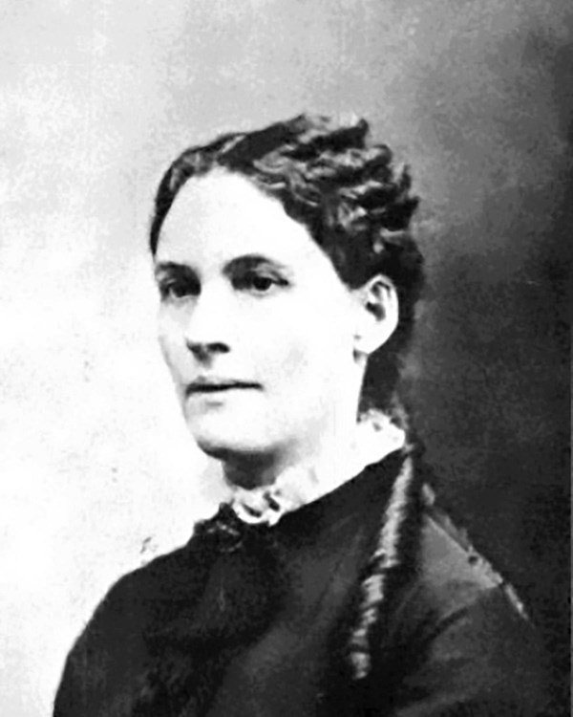
https://www.nps.gov/people/julia-archibald-holmes.htm

Bloomer Costume | GUIDING QUESTIONS:  - How did this costume reflect the women‘s movement of the time period and the values of Julia Archibald Holmes?  - How did the outfit change how women traveled on the trail?  - What was the criticism from people about the outfit on the Santa Fe Trail?
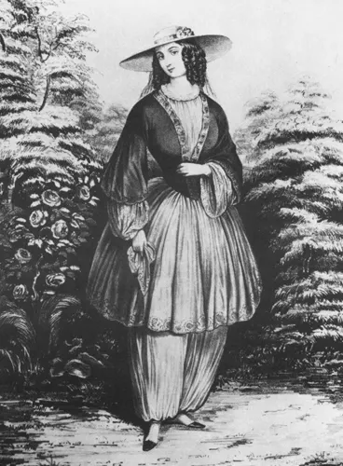
https://www.nps.gov/articles/000/bloomers-on-the-trail.htm

Cathay Williams : Santa Fe Trail Association | GUIDING QUESTIONS  - Why did Cathay Williams make an effort to hide her gender during this time period?  - How did Cathay Williams actually escape slavery and serve in the military?  - What was unique about the role Cathay Williams played in the Civil War with the particular company she served in?  - Cathay Williams served in multiple roles on the Santa Fe Trail. What did she do in New Mexico and Trinidad?  - Why would it be important to document her story for the future?
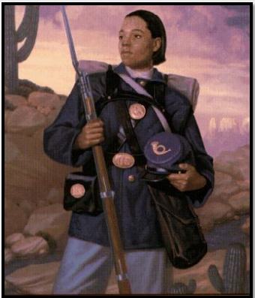

https://www.santafetrail.org/about-us/hall-of-fame/pdf/Inductees/Cathay-Williams.pdf .

Owl Woman | GUIDING QUESTIONS:  - How did Owl woman play an important role in the trading which occurred on the Santa Fe Trail?  - Based on this reading from the National Park Service, what was the critical role she played in negotiations with the native tribes?
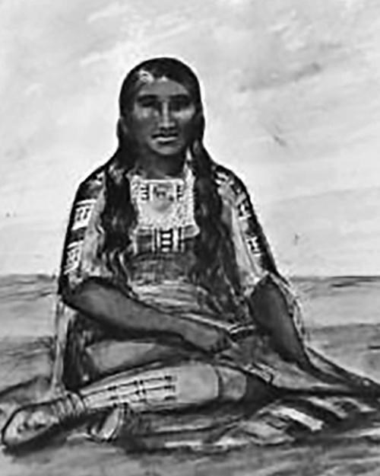

https://www.nps.gov/people/mistanta-owl-woman.htm

Assessment Question
How did women contribute to the ongoing success of the Santa Fe Trail and the advancement of women’s rights in the United States?
Response

