

2018 LOCAL CONTENT AND SERVICE

REPORT TO THE COMMUNITY



**“The community really enjoys paint night. We don’t get a lot of art in the school, so this is nice. Especially because the kids get to paint with their parents and guardians”.**

**Mann Elementary Principal Taj Jensen**

## KBTC Public Television is an active member of the community – spreading awareness, celebrating diversity and illuminating the paths of social discourse. We seek to engage viewers as citizens and encourage them to explore their world.

**LOCAL VALUE**

**2018 KEY SERVICES**

**LOCAL IMPACT**

**KBTC serves western Washington by providing high quality content that we acquire and produce about our community that engages, inspires and educates. This content can be accessed anytime, anyplace.**

**KBTC brings people together to explore and discuss issues of importance to the community, we call home.**

**Educate and support youth through *Ready to Learn* partnerships with organizations whose purpose is to ensure young learners get a good start in life and are prepared for school.**

**In 2018, KBTC engaged with the community through events and screenings with panel discussions.**

**We collaborated with community partners to provide activities for children and families such as monthly PBS Play dates, Spring & Summer Day Camps, Family Nights as well as Paint Nights incorporating STEAM concepts.**

**Recognized Champions for Children.**

***Northwest Now* continued examining issues and concerns of vital interest to our community!**

**KBTC reaches 1.8 million TV Households and over 4 million viewers.**

**Our Community engagement activities reach over 5 thousand families. Our partnership activities provide opportunities to explore, learn and play in settings some children might not otherwise have a chance to visit.**

***Northwest Now*, our weekly public affairs program produces more than 30 on-air and online programs yearly. They take place in the studio and the community!**



2018 LOCAL CONTENT AND SERVICE REPORT

**IN THE COMMUNITY**

#### **KBTC** is the South Sound’s Public Broadcasting Station. Operating out of Tacoma, Washington, **KBTC** is the only television broadcaster in Pierce County with programming services that reach throughout Western Washington.

**<Station logo**

**here>**

We are committed to telling local stories not told anywhere else, serving underserved and diverse audiences, and connecting viewers with the people and ideas that shape our community. **KBTC** is available to 1.8 million TV households and 4.3 million viewers in Western Washington, British Columbia and Oregon.

Our 2018 accomplishments represent unique partnerships with educational institutions, local non- profits and social service organizations, content producers, viewers, and members.

**EXPLORE YOUR WORLD**

**KBTC** is the only digital, high definition broadcasting production facility in Western Washington south of King County (Seattle). At **KBTC,** we believe that Western Washington viewers deserve a choice. Our digital broadcast service includes four programming streams:

**KBTC**-1 (HD) is our primary, high definition service that includes a variety of **PBS**, **APT**, **NETA**, Executive Program Services, Acorn, and **BBC** favorites as well as **KBTC** documentaries, specials, and series such as *Northwest Now* and select local content from local partner producers*.*

**KBTC**- 2 (HD) provides viewers with access to **NHK World Japan**, an all English language public media television channel filled with international news, business, technology and science information; and lifestyles, culture and travel programs produced and presented from Japanese and Asian perspectives.

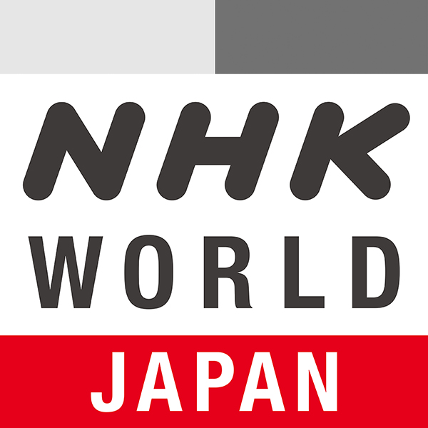 

#### **KBTC**- 3 (SD) provides news, public affairs, and entertainment from around the world, including Deutsche Welle, France 24, to name but a few. The channel also includes independent producers and original **MHz Network** productions. **MHz Worldview** on **KBTC**-3 serves as a liaison in bringing programs and understanding from around the world to Western Washington audiences.

**KBTC**- 4 (SD) provides coverage of state government and politics. **TVW** is available on the web and Comcast Cable. That leaves a large number of viewers without access. **KBTC** partners with **TVW** to providethis content over the air 24/7.



2018 LOCAL CONTENT AND SERVICE REPORT

**IN THE COMMUNITY**

**KBTC Public Television** is committed to telling local stories not told anywhere else, serving underserved and diverse audiences, and convening conversations that connect viewers with the people and ideas that shape our community.

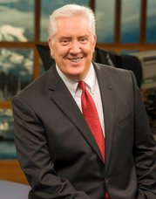Since 2012, Tom Layson has served as **KBTC**’s Producer and[](http://pbs.org/video/3005134592/) host of *Northwest Now*, our weekly Friday night public affairs program. Under Tom’s leadership, viewers have come to count on interesting guests, provocative topics, and great storytelling.

Tom and his guests go beyond the headlines to provide the context people need to more fully understand the issues that affect all of us in Western Washington. Hundreds of regional and national thought leaders, policy experts and newsmakers have appeared on the program. The award winning show also covers arts & culture and includes content shot in the field as well as in-studio.

**Northwest Now Highlights**

[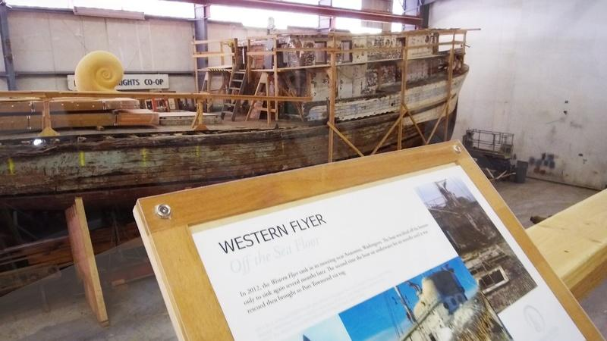](https://www.pbs.org/video/western-flyer-spsn1t/)

This season’s programs included an examination of school shootings and discussion of what it will take to make them safe again, a look at homelessness in the African American community, the opioid epidemic here and a feature on the restored Western Flyer – made famous by John Steinbeck in the book, *Sea of Cortez*.

*Northwest Now* programs are streamed on demand on kbtc.org where viewers can also find podcast previews of upcoming programs, and watch short-form *Northwest Now Digital First* features with Chris Anderson and recently created *Northwest Conversations*.

**Local & Regional Content**

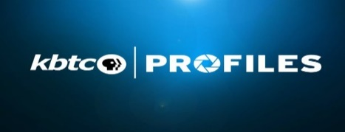**KBTC** launched a new series of short stories titled **KBTC** *Profiles*. The series tells the stories of people and places in our region. Using PBS’ The Vietnam War series, **KBTC** introduced **KBTC** *Profiles* through *Vietnam* *Perspectives*, interviews with local people speaking to their experience during the war as a complement to the national series. The regional series will continue with a focus on local, and sometimes lighter, human-interest stories.



2018 LOCAL CONTENT AND SERVICE REPORT

**ENGAGING WITH THE COMMUNITY**

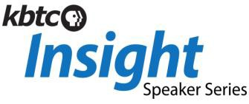**KBTC** engages the community through screenings, meet-ups and educational services:

**<Station logo**

**here>**

A speaker series featuring experts from the arts, education, the environment and history sharing their insights on creativity and their field. Captured in studio in an intimate setting, the talks and presentations are streamed online at kbtc.org.

## KBTC KIDS

## Educates and supports youth in our community. KBTC Kids integrates PBS KIDS resources into out-of-school settings for expanded learning opportunities. The activities are tailored to the location and participants.

##### Spring Break & Summer Break Camps

##### https://static.wixstatic.com/media/d60dcb_1ae56945e6414b07b12a77590891a304~mv2_d_1512_2016_s_2.jpg/v1/fill/w_183,h_244,al_c,q_80,usm_0.66_1.00_0.01/d60dcb_1ae56945e6414b07b12a77590891a304~mv2_d_1512_2016_s_2.jpg https://static.wixstatic.com/media/d60dcb_73a4f9fed5184dff9e0c65f5a507af3f~mv2.jpg/v1/fill/w_262,h_153,al_c,q_80,usm_0.66_1.00_0.01/d60dcb_73a4f9fed5184dff9e0c65f5a507af3f~mv2.jpg

##### KBTC partnered with Metro Parks Tacoma at Wapato Exploration Day Camp

##### After School Programs including computer labs, STEM based activities, reading, homework help and snacks in several locations including Tacoma Housing Authority locations and elementary schools.

##### Family Programs, including Paint Nights and Family Creative Learning Workshops.

##### Community partners:

Tacoma Public Schools YMCA

Tacoma Housing Authority Graduate Tacoma

United Way Pierce County Bates Child Studies

Peace Community Center United Way Pierce County

Children’s Museum of Tacoma MetroParks

First 5 FUNdamentals Pierce County Libraries



2018 LOCAL CONTENT AND SERVICE REPORT

**STORIES OF IMPACT**

***Encouraging Literacy***

# https://static.wixstatic.com/media/d60dcb_476b088ca77b4af38b60cf5b870bdf6e~mv2_d_2988_5312_s_4_2.jpg/v1/fill/w_133,h_236,al_c,q_80,usm_0.66_1.00_0.01/d60dcb_476b088ca77b4af38b60cf5b870bdf6e~mv2_d_2988_5312_s_4_2.jpg KBTC in partnership with Tacoma Rotary 8, Project Child Success and East Side Family Support Center build and install a Little Free Library as part of the Little Free Library Exchange Program.

**<Station logo here>**

***Providing Comfort***

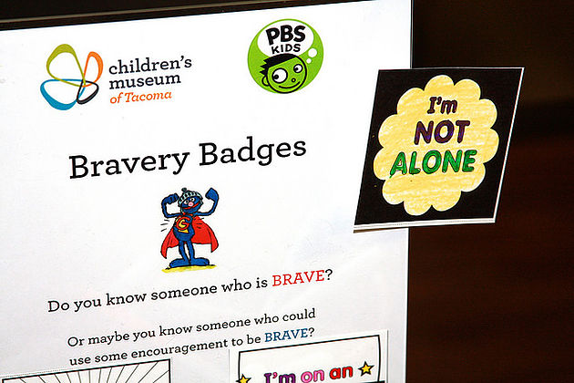 

# “Elmo and the Sesame Street characters have helped my little sister a lot. She has a hard time when Dad leaves” a young boy shared at the Tacoma Children’s Museum, referencing his dad’s deployment.

# KBTC partners with the Children’s Museum every month to provide PBS Play Date activities for children and their families.



2018 LOCAL CONTENT AND SERVICE REPORT

**STORIES OF IMPACT**

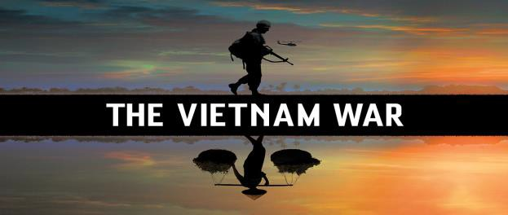

**KBTC Profiles**

***VIETNAM PERSPECTIVES***

Interested in localizing PBS’s ***The Vietnam War*, KBTC** aired the series in the spring of 2018after convening a group of volunteers including Vietnam Veterans, civilians; members of the local Vietnamese community, community agencies and other interested persons to screen and discuss the series. The station was looking for guidance on how to give local context and relevance to the series. One of the outcomes included production of a new series called **KBTC** *Profiles.* The serieslaunched including feature interviews with individuals providing*Vietnam Perspectives.* This same group of advisors will go on to provide guidance for a series to be featured next year called *Veterans Coming Home*.

*“It was an honor and a privilege to join you and others last week for the movie pre-view. Thank you for the opportunity to participate. I wanted to let you know that I’m interested in continuing with the dialogue.”*

*Therese Pasquier, Vietnam War refugee*

“*I believe the Vietnam War preview screening and dialogue are worthwhile opportunities for community engagements. Kudos to KBTC for taking on this community challenge.”*

*Alvin Nurse, Vietnam War veteran*

**Reach in the Community:**

In partnership with King and Pierce County Libraries, local Veterans groups and individuals **KBTC** screened documentaries about the Vietnam War in several communities and provided a moderated forum for discussion following the screenings.

### Partnerships:

Included veterans, civilians, educators, local libraries and agencies

### Impact and Community Feedback:

The feedback was positive and supportive of the station’s efforts to involve community members and a forum for discussion.



### KBTC provides many different services to western Washington residents

* Giving children a chance to be successful through *Ready to Learn*

#### Spring & Summer Break Camps for children

* Convening screenings of programs to foster and encourage dialogue and celebrate diversity
* Connecting with the community through events and planned meet-ups
* Examination of local issues and concerns on *Northwest Now*

#### Celebrating the arts through storytelling

* Partnering with like-minded, mission oriented organizations

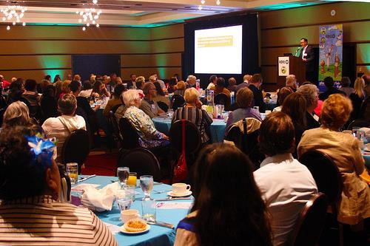

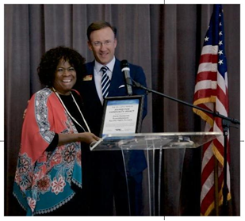

#### Tacoma Public Schools Superintendent **Carla Santorno** was the recipient of the **2018 William P. Mohler Community Impact Award**

**KBTC**’s Annual Community Breakfast Presenting the Award for Community Impact



2018 LOCAL CONTENT AND SERVICE REPORT

**SUMMARY**

**<Station logo here>**

### KBTC Public Television is proud to serve communities in western Washington, and our neighbors in Oregon and Canada!

**KBTC’s mission is to engage viewers, communities and supporters by delivering media experiences that educate, inspire and entertain!**