
2018 LOCAL CONTENT AND SERVICE
REPORT TO THE COMMUNITY

“The community really enjoys paint night. We don’t get a lot of art in the school, so this is nice. Especially because the kids get to paint with their parents and guardians”.

Mann Elementary Principal Taj Jensen

KBTC Public Television is an active member of the community – spreading awareness, celebrating diversity and illuminating the paths of social discourse. We seek to engage viewers as citizens and encourage them to explore their world.

LOCAL VALUE

2018 KEY SERVICES

LOCAL IMPACT

KBTC serves western Washington by providing high quality content that we acquire and produce about our community that engages, inspires and educates. This content can be accessed anytime, anyplace.

KBTC brings people together to explore and discuss issues of importance to the community, we call home.

Educate and support youth through Ready to Learn partnerships with organizations whose purpose is to ensure young learners get a good start in life and are prepared for school.
In 2018, KBTC engaged with the community through events and screenings with panel discussions.

We collaborated with community partners to provide activities for children and families such as monthly PBS Play dates, Spring & Summer Day Camps, Family Nights as well as Paint Nights incorporating STEAM concepts.

Recognized Champions for Children.

Northwest Now continued examining issues and concerns of vital interest to our community!
KBTC reaches 1.8 million TV Households and over 4 million viewers.

Our Community engagement activities reach over 5 thousand families. Our partnership activities provide opportunities to explore, learn and play in settings some children might not otherwise have a chance to visit.

Northwest Now, our weekly public affairs program produces more than 30 on-air and online programs yearly. They take place in the studio and the community!



2018 LOCAL CONTENT AND SERVICE REPORT
IN THE COMMUNITY

KBTC is the South Sound’s Public Broadcasting Station. Operating out of Tacoma, Washington, KBTC is the only television broadcaster in Pierce County with programming services that reach throughout Western Washington.
<Station logo
here>

We are committed to telling local stories not told anywhere else, serving underserved and diverse audiences, and connecting viewers with the people and ideas that shape our community. KBTC is available to 1.8 million TV households and 4.3 million viewers in Western Washington, British Columbia and Oregon.

Our 2018 accomplishments represent unique partnerships with educational institutions, local non- profits and social service organizations, content producers, viewers, and members.

EXPLORE YOUR WORLD

KBTC is the only digital, high definition broadcasting production facility in Western Washington south of King County (Seattle). At KBTC, we believe that Western Washington viewers deserve a choice. Our digital broadcast service includes four programming streams:

KBTC-1 (HD) is our primary, high definition service that includes a variety of PBS, APT, NETA, Executive Program Services, Acorn, and BBC favorites as well as KBTC documentaries, specials, and series such as Northwest Now and select local content from local partner producers.

KBTC- 2 (HD) provides viewers with access to NHK World Japan, an all English language public media television channel filled with international news, business, technology and science information; and lifestyles, culture and travel programs produced and presented from Japanese and Asian perspectives.

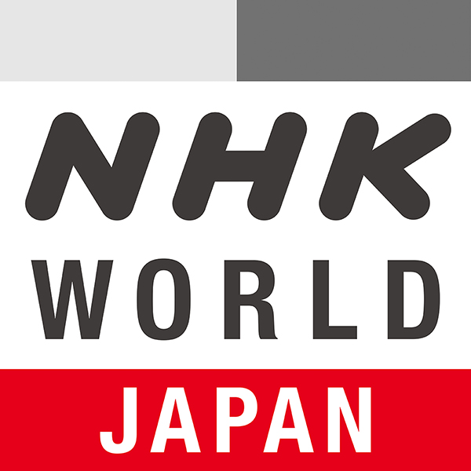

KBTC- 3 (SD) provides news, public affairs, and entertainment from around the world, including Deutsche Welle, France 24, to name but a few. The channel also includes independent producers and original MHz Network productions. MHz Worldview on KBTC-3 serves as a liaison in bringing programs and understanding from around the world to Western Washington audiences.

KBTC- 4 (SD) provides coverage of state government and politics. TVW is available on the web and Comcast Cable. That leaves a large number of viewers without access. KBTC partners with TVW to provide this content over the air 24/7.

2018 LOCAL CONTENT AND SERVICE REPORT
IN THE COMMUNITY

KBTC Public Television is committed to telling local stories not told anywhere else, serving underserved and diverse audiences, and convening conversations that connect viewers with the people and ideas that shape our community.

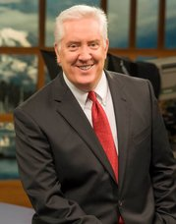

Since 2012, Tom Layson has served as KBTC’s Producer and host of Northwest Now, our weekly Friday night public affairs program. Under Tom’s leadership, viewers have come to count on interesting guests, provocative topics, and great storytelling.

Tom and his guests go beyond the headlines to provide the context people need to more fully understand the issues that affect all of us in Western Washington. Hundreds of regional and national thought leaders, policy experts and newsmakers have appeared on the program. The award winning show also covers arts & culture and includes content shot in the field as well as in-studio.

Northwest Now Highlights
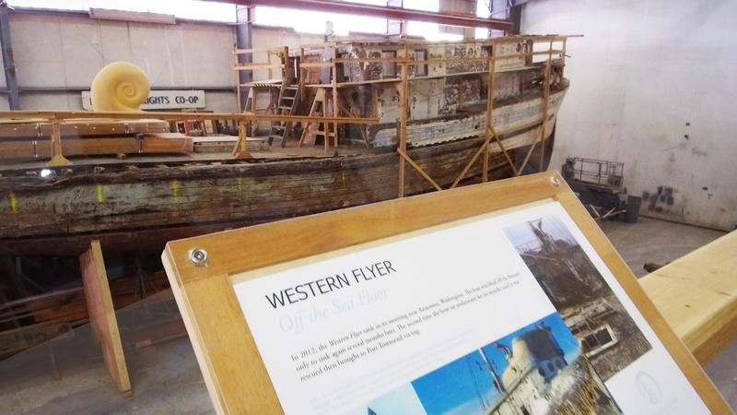
This season’s programs included an examination of school shootings and discussion of what it will take to make them safe again, a look at homelessness in the African American community, the opioid epidemic here and a feature on the restored Western Flyer – made famous by John Steinbeck in the book, Sea of Cortez.

Northwest Now programs are streamed on demand on kbtc.org where viewers can also find podcast previews of upcoming programs, and watch short-form Northwest Now Digital First features with Chris Anderson and recently created Northwest Conversations.

Local & Regional Content

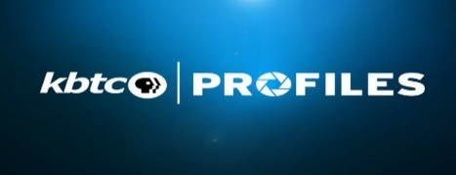
KBTC launched a new series of short stories titled KBTC Profiles. The series tells the stories of people and places in our region. Using PBS’ The Vietnam War series, KBTC introduced KBTC Profiles through Vietnam Perspectives, interviews with local people speaking to their experience during the war as a complement to the national series. The regional series will continue with a focus on local, and sometimes lighter, human-interest stories.

2018 LOCAL CONTENT AND SERVICE REPORT
ENGAGING WITH THE COMMUNITY

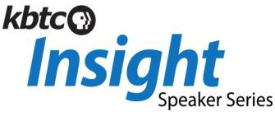
KBTC engages the community through screenings, meet-ups and educational services:
<Station logo
here>
A speaker series featuring experts from the arts, education, the environment and history sharing their insights on creativity and their field. Captured in studio in an intimate setting, the talks and presentations are streamed online at kbtc.org.

KBTC KIDS

Educates and supports youth in our community. KBTC Kids integrates PBS KIDS resources into out-of-school settings for expanded learning opportunities. The activities are tailored to the location and participants.

Spring Break & Summer Break Camps

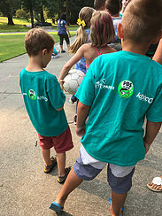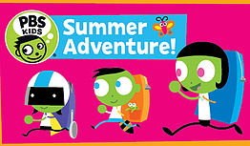

KBTC partnered with Metro Parks Tacoma at Wapato Exploration Day Camp

After School Programs including computer labs, STEM based activities, reading, homework help and snacks in several locations including Tacoma Housing Authority locations and elementary schools.

Family Programs, including Paint Nights and Family Creative Learning Workshops.

Community partners:

Tacoma Public Schools YMCA
Tacoma Housing Authority Graduate Tacoma
United Way Pierce County Bates Child Studies
Peace Community Center United Way Pierce County
Children’s Museum of Tacoma MetroParks
First 5 FUNdamentals Pierce County Libraries

2018 LOCAL CONTENT AND SERVICE REPORT
STORIES OF IMPACT

Encouraging Literacy

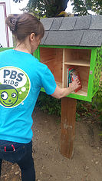 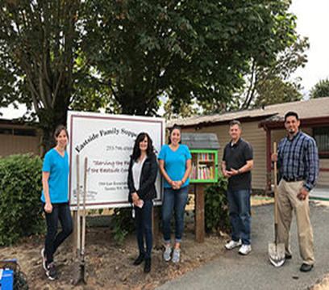 KBTC in partnership with Tacoma Rotary 8, Project Child Success and East Side Family Support Center build and install a Little Free Library as part of the Little Free Library Exchange Program.
<Station logo here>

Providing Comfort

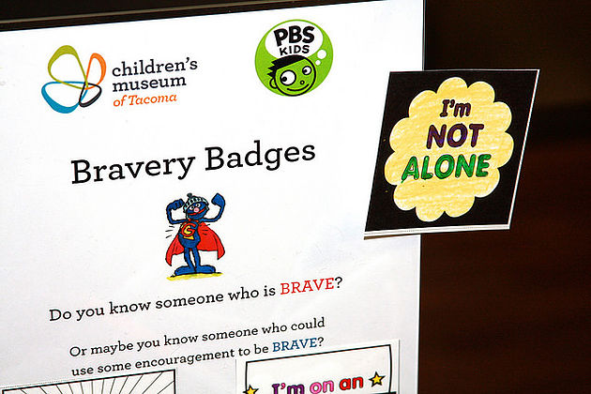

“Elmo and the Sesame Street characters have helped my little sister a lot. She has a hard time when Dad leaves” a young boy shared at the Tacoma Children’s Museum, referencing his dad’s deployment.

KBTC partners with the Children’s Museum every month to provide PBS Play Date activities for children and their families.

2018 LOCAL CONTENT AND SERVICE REPORT
STORIES OF IMPACT
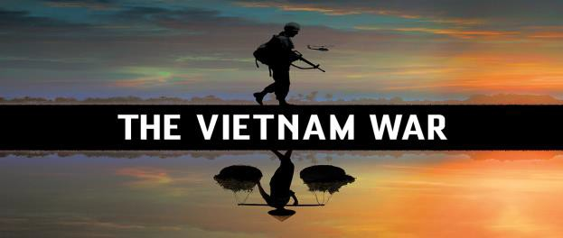

KBTC Profiles
VIETNAM PERSPECTIVES

Interested in localizing PBS’s The Vietnam War, KBTC aired the series in the spring of 2018 after convening a group of volunteers including Vietnam Veterans, civilians; members of the local Vietnamese community, community agencies and other interested persons to screen and discuss the series. The station was looking for guidance on how to give local context and relevance to the series. One of the outcomes included production of a new series called KBTC Profiles. The series launched including feature interviews with individuals providing Vietnam Perspectives. This same group of advisors will go on to provide guidance for a series to be featured next year called Veterans Coming Home.

“It was an honor and a privilege to join you and others last week for the movie pre-view. Thank you for the opportunity to participate. I wanted to let you know that I’m interested in continuing with the dialogue.”

Therese Pasquier, Vietnam War refugee

“I believe the Vietnam War preview screening and dialogue are worthwhile opportunities for community engagements. Kudos to KBTC for taking on this community challenge.”

Alvin Nurse, Vietnam War veteran

Reach in the Community:

In partnership with King and Pierce County Libraries, local Veterans groups and individuals KBTC screened documentaries about the Vietnam War in several communities and provided a moderated forum for discussion following the screenings.

Partnerships:

Included veterans, civilians, educators, local libraries and agencies

Impact and Community Feedback:

The feedback was positive and supportive of the station’s efforts to involve community members and a forum for discussion.



KBTC provides many different services to western Washington residents

- Giving children a chance to be successful through Ready to Learn

Spring & Summer Break Camps for children

- Convening screenings of programs to foster and encourage dialogue and celebrate diversity

- Connecting with the community through events and planned meet-ups

- Examination of local issues and concerns on Northwest Now

Celebrating the arts through storytelling

- Partnering with like-minded, mission oriented organizations

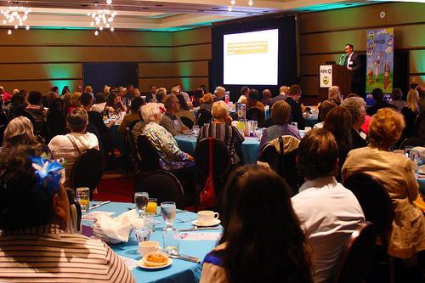

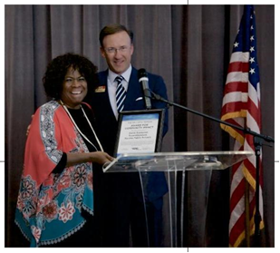

Tacoma Public Schools Superintendent Carla Santorno was the recipient of the 2018 William P. Mohler Community Impact Award

KBTC’s Annual Community Breakfast Presenting the Award for Community Impact

2018 LOCAL CONTENT AND SERVICE REPORT
SUMMARY

<Station logo here>

KBTC Public Television is proud to serve communities in western Washington, and our neighbors in Oregon and Canada!

KBTC’s mission is to engage viewers, communities and supporters by delivering media experiences that educate, inspire and entertain!

