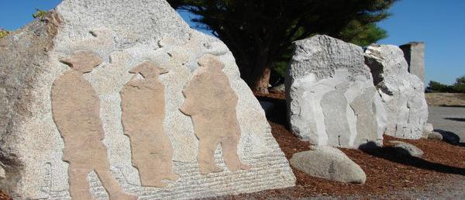
2017 LOCAL CONTENT AND SERVICE
REPORT TO THE COMMUNITY
“We’re excited to partner with KBTC. We
love our community, just like KBTC. We’re passionate about the local community, local stories, public affairs, everything that’s vibrant about the South Sound and we’re passionate about our partnership with KBTC.” Josh Dunn, Publisher South Sound Magazine

KBTC Public Television is an active member of the community – spreading awareness, celebrating diversity and illuminating the paths of social discourse. We seek to engage viewers as citizens and encourage them to explore their world.

LOCAL VALUE

2017 KEY SERVICES

LOCAL IMPACT

KBTC is committed to serving western Washington by providing high quality content that we acquire and produce about our community that engages, inspires and educates.

By convening gatherings to explore and discuss issues of importance to the community we serve we invite them in and we go where they are.

Through Ready to Learn partnerships with organizations whose purpose is to ensure young learners get a good start in life and are prepared for school.
In 2017, KBTC convened Community events and screenings with panel discussions on topics of importance and interest.

We collaborated with community groups to provide activities for children and families including monthly PBS Play dates, Spring & Summer Day Camps, Family Nights as well as Paint nights incorporating STEAM concepts.

Recognized Champions for Children and other individuals making an impact in our community

Northwest Now continues examining issues and concerns of vital interest to our community!
KBTC reaches 1.8 million TV Households and over 4 million viewers. We are the only broadcaster located in Tacoma, WA.

Our Community engagement activities reach over 5 thousand families. Our partnership activities provide opportunities to explore learn and play in settings some children may not otherwise have a chance to visit.

Northwest Now, our weekly public affairs program produces more than 30 on-air and online programs yearly. They take place in the studio and the community!

2017 LOCAL CONTENT AND SERVICE REPORT
IN THE COMMUNITY

KBTC is the South Sound’s Public Broadcasting Station. Operating out of Tacoma, Washington, KBTC is the only television broadcaster in Pierce County with programming services that reach throughout western Washington.
<Station logo
here>

We are committed to telling local stories not told anywhere else, serving underserved and diverse audiences, and connecting viewers with the people and ideas that shape our community. KBTC is available to 1.8 million TV households and 4.3 million viewers in western Washington, British Columbia and Oregon.

Our 2017 accomplishments represent unique partnerships with educational institutions, local non- profits and social service organizations, content producers, viewers, and members.

EXPLORE YOUR WORLD

KBTC is the only digital, high definition broadcasting production facility in western Washington south of King County (Seattle). At KBTC, we believe that western Washington viewers deserve a choice. Our digital broadcast service includes four programming streams:

KBTC-1 (HD) is our primary, high definition service that includes a variety of PBS, APT, NETA, Executive Programming, Acorn, and BBC favorites as well as KBTC documentaries, specials, and series such as Northwest Now and select content focusing on regional topics.

KBTC- 2 (HD) provides viewers with access to NHK World, an all English language public media television channel filled with international news, business, technology and science information; and lifestyles, culture and travel programs produced and presented from Japanese and Asian perspectives.

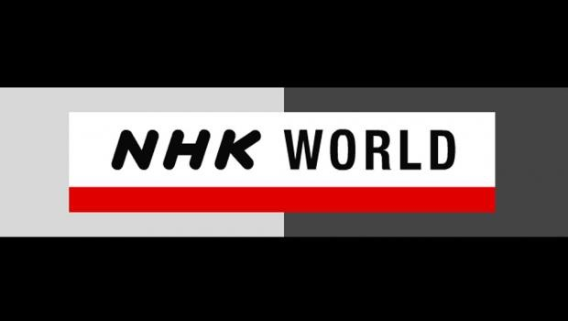

KBTC- 3 (SD) provides news, public affairs, and entertainment from around the world, including Al Jazeera English, Beijing TV, Deutsche Welle, euroNews, France 24, SABC News International, to name but a few. The channel also includes independent producers and original MHz Network productions. MHz Worldview on KBTC-3 serves as a liaison in bringing programs and understanding from around the world to western Washington audiences.

KBTC- 4 (SD) is one of our partnerships. TVW covers state government and politics and is available on the web and Comcast Cable. That leaves a large number of viewers without access. KBTC broadcasts the 24/7 TVW programming to serve these viewers.

2017 LOCAL CONTENT AND SERVICE REPORT
IN THE COMMUNITY

KBTC Public Television is committed to telling local stories not
told anywhere else, serving underserved and diverse audiences, and convening conversations that connect viewers with the people and ideas that shape our community.

Since 2012, Tom Layson has served as KBTC’s Producer and host of Northwest Now, our weekly Friday night public affairs program. Under Tom’s leadership, viewers have come to count on interesting guests, provocative topics, and great storytelling.

Tom and his guests go beyond the headlines to provide the context people need to more fully understand the issues that affect all of us in western Washington. Hundreds of regional and national thought leaders, policy experts and newsmakers have appeared on the program. The show also covers arts & culture and includes content shot in the field as well as in-studio.

Northwest Now Highlights

This season’s programs included interviews with candidates for mayor in Seattle and Tacoma, Governor Jay Inslee, and Attorney General Bob Ferguson. Issues included sexual violence, the homeless crisis in the south Sound, and the history of the expulsion of Chinese immigrants. Special programs included a half hour special about the restoration of a famous fishing boat with deep ties to the south Sound, and the story of a local craftsman who turned personal tragedy into a business.

Northwest Now programs are streamed on demand on kbtc.org where viewers can also find podcast previews of upcoming programs, and watch short-form Northwest Now Digital First with Chris Anderson features and newly created Northwest Conversations.

Local, Regional & Special Content

In 2017, KBTC broadcast content produced by local and regional producers highlighting the Pacific Northwest. Collaborating with NXNW Productions KBTC provided the series Washington Grown and the documentary The Gamble: The Washington Potato Story and from Cutboard Studios, the Way of the Columbia series.

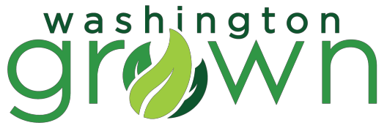

KBTC has begun developing a new series titled KBTC Profiles. This series will tell the story of people and places in our region. The series will launch in the spring of 2018 with Vietnam Perspectives as a local complement to KBTC’s airing of Ken Burns & Lynn Novick’s The Vietnam War.

KBTC celebrated the 30th Anniversary of airing Dr. Who Classics!

2017 LOCAL CONTENT AND SERVICE REPORT
ENGAGING WITH THE COMMUNITY

KBTC engages the community though screenings, meet-ups and educational services:
<Station logo
here>

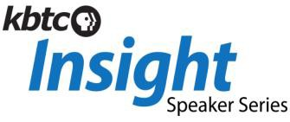A new speaker series feature experts from the arts, education, the environment and history. Captured in the studio, the presentations are streamed online at kbtc.org.

KBTC KIDS Programs
Integrate PBS KIDS resources into out-of-school settings for expanded learning opportunities. The activities are tailored to the location and participants.

Spring Break Camp:
McCarver Elementary
- Providing PBS KIDS based literacy, math, and science learning opportunities during spring break.

Summer Break Camps:
Lister Elementary
- Month long camp experience PBS KIDS curriculum and summer fun activities used to expand knowledge in the summer time.
Wapato Exploration Camp
- Incorporates a variety of PBS KIDS activities featuring a strong nature and science focus in unique day-camp experience in Wapato Park.

After School Programs:
Bergeson Terrace
- Computer lab in THA housing that provides a healthy, safe environment for students to be afterschool on weekdays providing snacks, homework help, reading, and STEM based activities.
Roosevelt Elementary
- Science and engineering opportunities for students grades 2nd-5th using engaging Ruff Ruffman curriculum.

Family Programs:
Paint Nights
- An opportunity for parents, educators, and caregivers to interact with their students through art in STEAM activities.
Family Creative Learning Workshops
- Creative learning opportunities for children and families to learn together.

Community partnerships:
Tacoma Public Schools Tacoma Housing Authority Puget Sound Educational Service District United Way Pierce County Children’s Museum of Tacoma YMCA
Graduate Tacoma First 5 Fundamentals
Peace Community Center Pierce County Libraries
Bates Child Studies Metro Parks Tacoma

2017 LOCAL CONTENT AND SERVICE REPORT
STORIES OF IMPACT

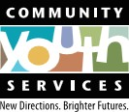
Foster Family Heroes
<Station logo here>

KBTC in partnership with Community Youth Services produced on-air spots highlighting the need for foster parents and the satisfaction of those who serve. This was a pilot project of the CYS.

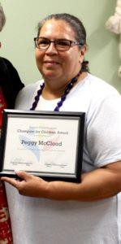
Champion for Children!

Each year, Project Child Success identifies and celebrates people in Pierce County who have made a significant impact in the lives of children and families. These are not just experts or professionals, but people from our community, representing all walks of life who have made a difference for children and families. 2017 recipient Peggy McCloud, Director of Grandview Early Learning Center

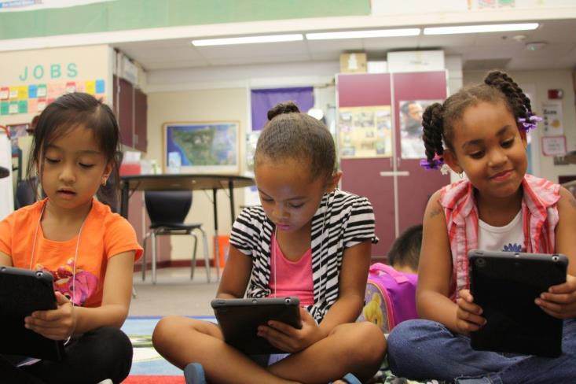
Enjoying Learning

KBTC and partners are in the schools. Here 1st grade students practice literacy and STEM concepts by playing PBS KIDS apps on tablets as part of KBTC’s annual summer camp at Lister Elementary School.

2017 LOCAL CONTENT AND SERVICE REPORT
STORIES OF IMPACT

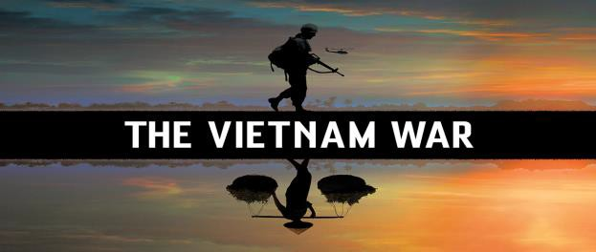
KBTC
VIETNAM PERSPECTIVES

KBTC convened a group of volunteers including Vietnam Veterans, civilians; members of the local Vietnamese community, community agencies and other interested persons to screen and discuss the Ken Burns/Lynn Novick series The Vietnam War. The station was looking for guidance on how to give local context to the series. One of the outcomes includes a new series of KBTC Profiles that will feature interviews with individuals entitled KBTC Vietnam Perspectives. The group continues to advise station staff on the project.

“It was an honor and a privilege to join you and others last week for the movie pre-view. Thank you for the opportunity to participate. I wanted to let you know that I’m interested in continuing with the dialogue.”

Therese Pasquier, Vietnam War refugee

“I believe the Vietnam War preview screening and dialogue are worthwhile opportunities for community engagements. Kudos to KBTC for taking on this community challenge.”

Alvin Nurse, Vietnam War veteran

Reach in the Community:

In partnership with King and Pierce County Libraries, local Veterans groups and individuals KBTC will screen documentaries about the war in several neighborhoods and provide a moderated forum for discussion following the screenings.

Partnerships:

Includes veterans, civilians, educators, local libraries and agencies

Impact and Community Feedback:

While this is an on-going project, the feedback has been very positive and supportive of the station’s efforts to involve the community, provide context and add more voices.

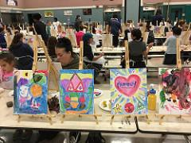

KBTC provides many different services to western Washington residents

- Giving children a chance to be successful through Ready to Learn

Spring & Summer Break Camps for children

- Convening screenings of programs to foster and encourage dialogue and celebrate diversity

- Connecting through events and planned meet-ups

- Examination of local issues and concerns on Northwest Now

Celebrating the arts through storytelling

- Partnering with like-minded, mission oriented organizations

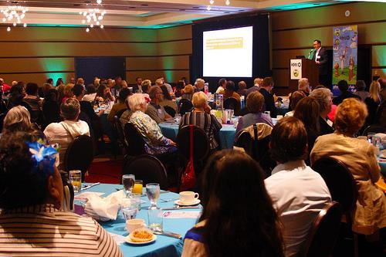

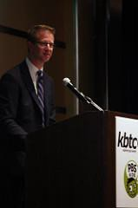

Congressman Derek Kilmer, this year’s recipient of the KBTC Community Impact Award

KBTC’s Annual Community Breakfast Presenting the Award for Community Impact

2017 LOCAL CONTENT AND SERVICE REPORT
SUMMARY

<Station logo here>

KBTC Public Television is proud to serve communities in western Washington, and our neighbors in Oregon and Canada!

KBTC’s mission is to engage viewers, communities and supporters by delivering media experiences that educate, inspire and entertain!

