2020 LOCAL CONTENT AND SERVICE
REPORT TO THE COMMUNITY

Thank you for your inspired choice to bring FNX to KBTC!!! 28.3 is now my favorite station. I've learned so much from watching. Really outstanding programming!

KBTC Public Television is an active member of the community – spreading awareness, celebrating diversity and illuminating the paths of social discourse. We seek to engage viewers as citizens and encourage them to explore their world.

LOCAL VALUE

2020 KEY SERVICES

LOCAL IMPACT

KBTC serves western Washington by providing high quality content that we acquire and produce about our community that engages, inspires and educates. This content can be accessed anytime, anyplace via kbtc.org.

KBTC brings people together to explore and discuss issues of importance to the community we call home.

Educate and support youth through Ready to Learn partnerships with organizations whose purpose is to ensure young learners get a good start in life and are prepared for school.
In 2020, KBTC engaged with the community through events and screenings with panel discussions.

We collaborated with community partners to provide activities for children and families such as monthly PBS Play dates, Spring & Summer Day Camps, Family Nights, afterschool programs as well as Paint Nights incorporating STEAM concepts.

Recognized Champions for Children.

Northwest Now continued examining issues and concerns of vital interest to our community!
KBTC reaches 1.8 million TV Households and over 4 million viewers.

KBTC Staff provided educational activities for K-5 based on PBS Kids content. The programs are offered throughout the school year, 2-3 times per week at multiple sites. When the pandemic hit, staff provided learning activities and snacks for pick-up in Grab ‘n’ Go packets.

Northwest Now, KBTC’s weekly public affairs program produces more than 30 on-air and online programs yearly. They take place in the studio and the community!

2020 LOCAL CONTENT AND SERVICE REPORT
IN THE COMMUNITY

KBTC is the South Sound’s Public Broadcasting Station. Operating out of Tacoma, Washington, KBTC is the only television broadcaster in Pierce County with programming services that reach throughout Western Washington from the Oregon border to the Canadian border.
<Station logo
here>

We are committed to telling local stories not told anywhere else, serving underserved and diverse audiences, and connecting viewers with the people and ideas that shape our community. KBTC is available to 1.8 million TV households and 4.3 million viewers in Western Washington, British Columbia and Oregon.

Our 2020 accomplishments represent unique partnerships with educational institutions, local non- profits and social service organizations, content producers, viewers, and members.

EXPLORE YOUR WORLD

KBTC is the only digital, high definition broadcasting production facility in Western Washington south of King County (Seattle). At KBTC, we believe that Western Washington viewers deserve a choice. Our digital broadcast service includes four programming streams:

KBTC-1 (HD) is our primary, high definition service that includes a variety of PBS, APT, NETA, Executive Program Services, Acorn, and BBC favorites as well as KBTC documentaries, specials, and series such as Northwest Now and select local content from local partner producers.

KBTC- 2 (HD) provides viewers with access to NHK World Japan, an all English language public media television channel filled with international news, business, technology and science information; and lifestyles, culture and travel programs produced and presented from Japanese and Asian perspectives.
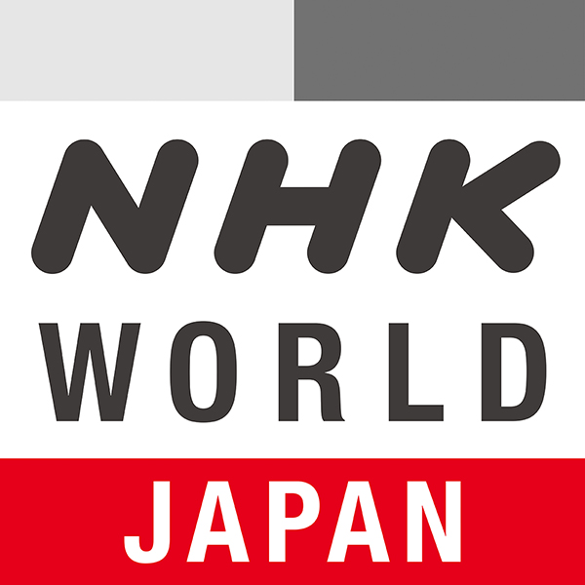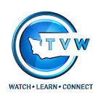

KBTC- 3 (SD) provides FNX | First Nations Experience. In February 2020, KBTC added FNX to the broadcast schedule. FNX is the first and only broadcast television network in the US exclusively devoted to Native American and World Indigenous content.

KBTC- 4 (SD) provides coverage of state government and politics. TVW is available on the web and Comcast Cable. That leaves a large number of viewers without access. KBTC partners with TVW to provide this content over the air 24/7.

2020 LOCAL CONTENT AND SERVICE REPORT
IN THE COMMUNITY

KBTC Public Television is committed to telling local stories unique to our region, serving underserved and diverse audiences, and convening conversations that connect viewers with the people and ideas that shape our community.
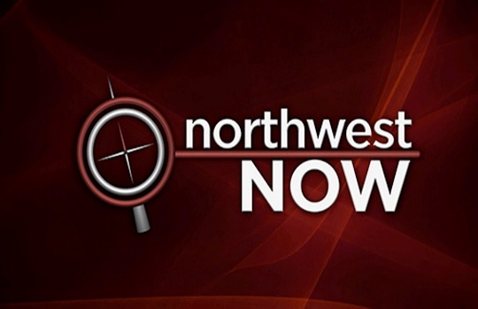
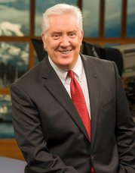
Since 2012, Tom Layson has served as KBTC’s Producer and host of Northwest Now, our weekly Friday night public affairs program. Under Tom’s leadership, viewers have come to count on interesting guests, provocative topics, and great storytelling.

Tom and his guests go beyond the headlines to provide the context people need to more fully understand the issues that affect all of us in Western Washington. Hundreds of regional and national thought leaders, policy experts and newsmakers have appeared on the program. The award winning show also covers arts & culture and includes content shot in the field as well as in-studio.

Northwest Now Highlights
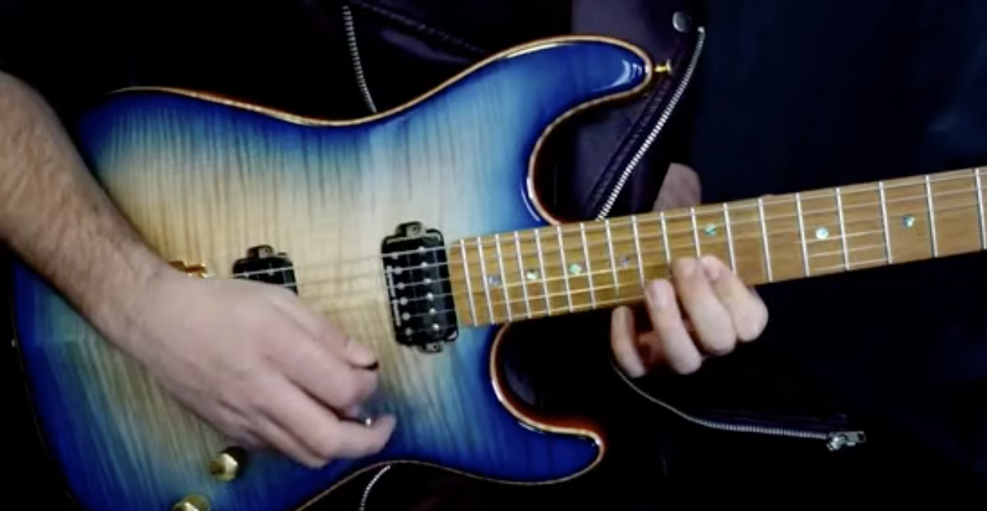
This season’s programs included a series of conversations focused on the local economy, the legislative session with Governor Inslee, Black History month with Dr. Quintard Taylor and a special documentary on the makers of guitars in the northwest. The special titled “Attack, Decay, Sustain, Release” featured music performance, and examined the long and rich history of building guitars. It nicely complimented Ken Burns” Country Music. This special was recognized by the Society of Professional Journalists and the Telly Awards, honoring excellence in video and television.

Once the coronavirus pandemic hit, the show’s producers scrambled to provide up to date information on the virus, including daily on-air messages and streamed recaps of Governor Inslee’s press briefings detailing the status of the virus in the state and lock-down mandates and guidelines for social distancing.

Northwest Now Digital First featured short stories on the Tacoma Art Museum, the Peace Bus, Grave Concerns, and Mt. St. Helens 40th Anniversary. Once the pandemic hit, much of the focus turned to daily press briefings on COVID-19.

Northwest Now programs are streamed on demand on kbtc.org where viewers can also find podcast previews of upcoming programs and watch short-form Northwest Now Digital First stories.

2020 LOCAL CONTENT AND SERVICE REPORT
LOCAL & REGIONAL CONTENT
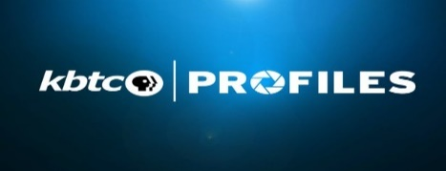
KBTC’s on-air and online short-form series of stories about the people, places and events in and around our Western Washington community. From artists to Buffalo Soldiers riding motorcycles, to the story of Tacoma’s origins, these stories capture our unique region.

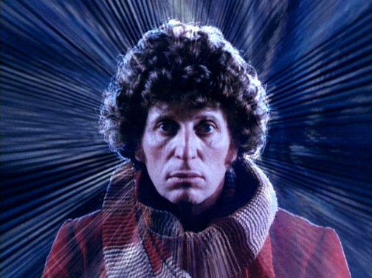
Who doesn’t love a Dr. Who Marathon?! Twice a year KBTC broadcasts a special pledge event featuring programs from Dr. Who classics!

Another favorite of our donors is the Saturday Sewing line-up and marathon! Donors look forward to getting tips and creative ideas!

Regional

The Peace Queen documentary highlighting the 2018 Greater Tacoma Peace Prize Laureate. Denise Melannie Cunningham, also known as, The Peace Queen, documented the activities of her year serving as the Tacoma Peace Prize Laureate, including her trip to Oslo Norway. She was recognized for her life-long work toward racial reconciliation.

Working in partnership with Pacific Northwest filmmaker Shane Anderson, KBTC broadcast two of his environmental films. A River’s Last Chance on the recovery of the Eel River in Northern California and Chehalis: A Watershed Moment, which “explores the intersection of social, cultural, economic and environmental values that are increasingly re-defined by new climate realities.”

Washington Grown - this regionally produced program features stories about food going from the field to the table. We meet the farmers responsible for growing what we eat and are treated to great recipes! Health and nutrition, “It’s all about food!”

“The programming on this channel is wonderful. Thank you for providing an informative and enjoyable viewing for all.”

2020 LOCAL CONTENT AND SERVICE REPORT
ENGAGING IN THE COMMUNITY

KBTC engages the community through educational activities with youth and families and through screenings and events.
<Station logo
here>
<Station logo
here>

KBTC Kids & Family

KBTC, in partnership with the Tacoma Housing Authority, served families in our community through our academic enrichment program. We hosted weekly in-person workshops for youth in two different neighborhoods to engage in educational PBS KIDS games and activities. The site coordinators developed trusted relationships with the kids and their families, who continue to count on the station to support their academic needs during distance learning.

After the spring time events of the pandemic forcing schools to close and the Black Lives Matter protests, the KBTC Kids team identified community needs and provided resources and PBS Kids activities to help parents address these issues in an age appropriate way.

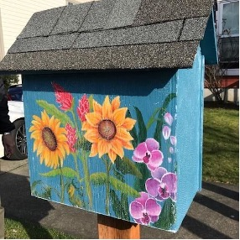
Grab & Go

Little Free Libraries

For families looking for fun hands-on activities to do during this time, our KBTC team replenished activities in Little Free Libraries in the Eastside and Hilltop communities of Tacoma. From Ruff Ruffman to Odd Squad, to PBS Parents Arts & Crafts and more. Click here to view Little Free Libraries locations, a pdf of activities that have been distributed during school closures and more!

Race & Diversity

Children’s books are one of the most effective tools to engage young children on important issues! KBTC Kids team provided lists of books to read and encourage conversations about race and diversity.

2020 LOCAL CONTENT AND SERVICE REPORT
STORIES OF IMPACT

At-Home Learning

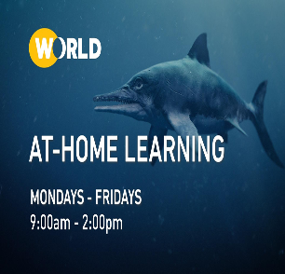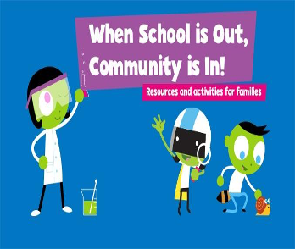
<Station logo here>

KBTC, in partnership with the Office of the State Superintendent of Public Education and other public media stations in the state provided over the air educational resources for At-Home Learning.

Serving Community Needs

Informed the public on the pandemic, needed resources and Governor Inslee’s mandates

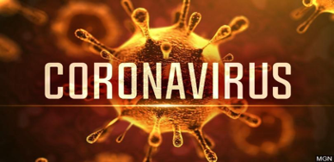

KBTC Values Diversity & Equity

KBTC provided locally produced stories and programs on racial equity.

KBTC provided online links to PBS programs that provided truth and history focusing on race and diversity.

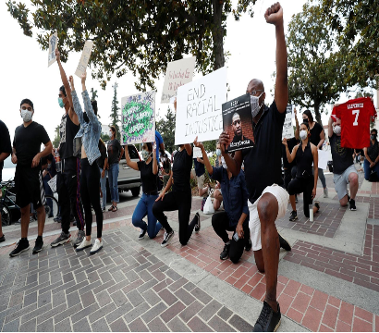

2020 LOCAL CONTENT AND SERVICE REPORT
STORIES OF IMPACT

A Challenging and Rewarding Year

Everyone’s lives were touched and impacted by the coronavirus pandemic. KBTC Public Television has provided up-to-date information through local productions such as Northwest Now and Digital First segments. Web pages on kbtc.org have been devoted to links and resources. KBTC TV continued providing excellent, high quality programs the community has come to expect.

“This Fascism program is incredibly disturbing and extremely important now for the US.”

"We love KBTC programming, but Rick’s fascism show and the message incorporated is so important that we feel we have to support that show in particular.”

“Thank you for the important work you all do! Now more than ever we need quality sources of media from organizations we can trust!”

Educational resources have been provided to help bridge gaps and access to quality learning through At Home Learning - five hours of educational programs M-F for 6-12 grades as well as seven hours of PBS Kids programs for pre-k-5th grade both services are free over-the-air. On kbtc.org links to online educational resources for parents and educators through PBS Learning Media were made available. KBTC and all the public television stations in the state partnered with the Office of Public Instruction to connect educators to resources to support their educational efforts throughout the pandemic. This was the first time for this partnership. Existing education partnerships with Tacoma Public Schools and the Tacoma Housing Authority gave staff the opportunity to give Grab & Go activity packets with meals to families in underserved communities in our region. Traditionally these activities would have been provided in-person after-school. The pandemic didn’t keep our dedicated staff from finding creative ways to continue the service!
While the entire country began to experience racial reckoning, KBTC shared resources online and on air provided by PBS of important, historical documentaries, programs, educational materials and locallyproduced stories and interivews to help give context to the impact of systemic racism. Throughout the years, KBTC has air important programs and held in-person and recently, virtual screenings and discussions to provide opportunities for conversations about these important issues.

2020 LOCAL CONTENT AND SERVICE REPORT
SUMMARY

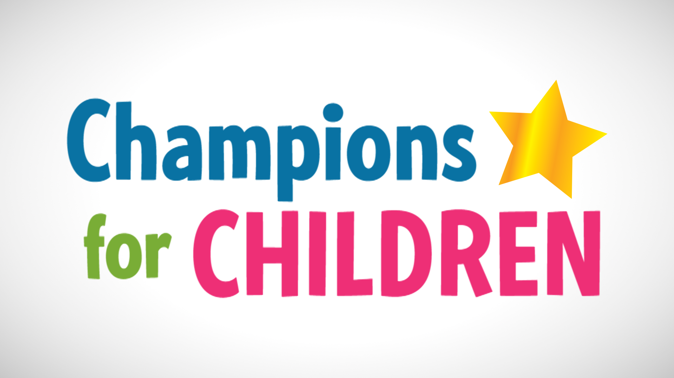

KBTC provides many different services to western Washington residents

- Giving children a chance to be successful through Ready to Learn

Spring & Summer Break Camps for children

- Convening screenings of programs to foster and encourage dialogue and celebrate diversity

- Connecting with the community through events

- Examination of local issues and concerns on Northwest Now and Digital First

KBTC Profiles celebrates history, the arts and the environment through storytelling

- Partnering with like-minded, mission-oriented organizations

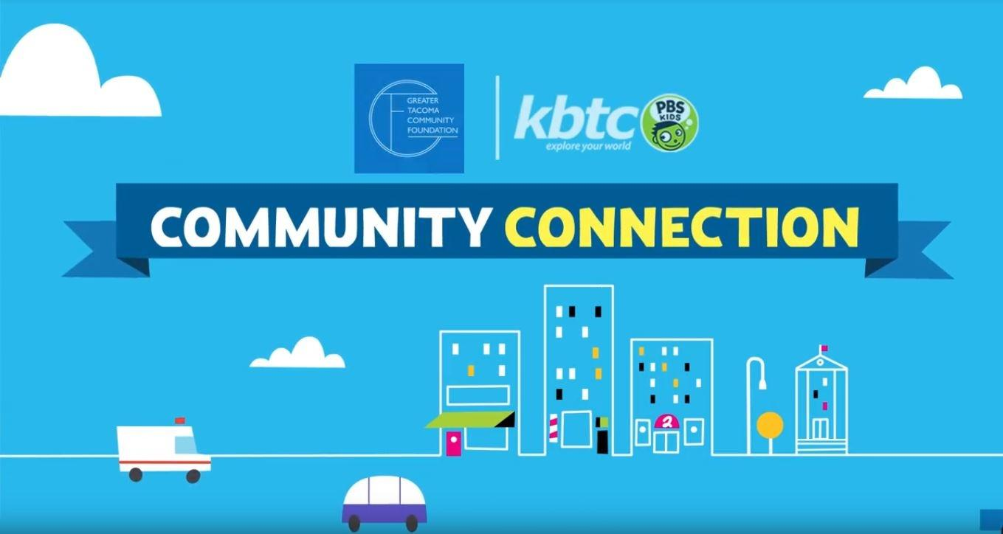

KBTC’s mission is to engage viewers, communities and supporters by delivering media experiences that educate, inspire and entertain!

KBTC’s vision is to be an active member of the community – spreading awareness, celebrating diversity and illuminating the paths of social discourse and growth!

- Connecting with the community through events

- Examination of local issues and concerns on Northwest Now and Digital First

KBTC Profiles celebrates history, the arts and the environment through storytelling

- Partnering with like-minded, mission-oriented organizations

