
2019 LOCAL CONTENT AND SERVICE
REPORT TO THE COMMUNITY
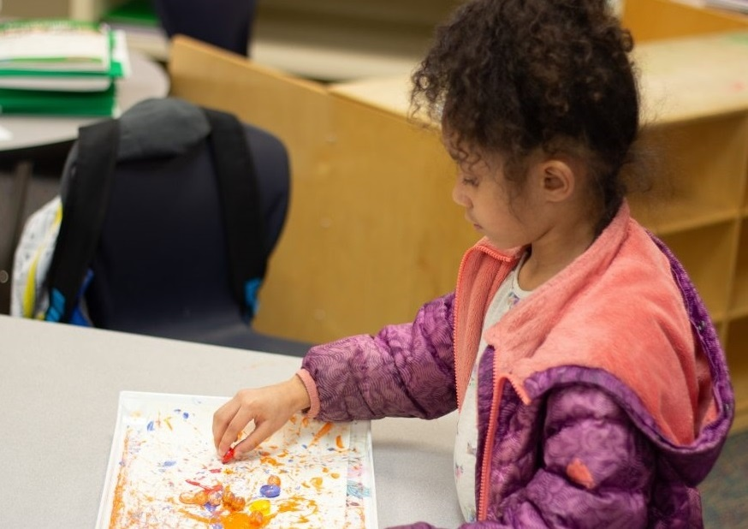

“I like it because it’s fun” – SadieSade, a student in KBTC’s afterschool STEM program at Reed Elementary School about the PBS Kids based science curriculum.

KBTC Public Television is an active member of the community – spreading awareness, celebrating diversity and illuminating the paths of social discourse. We seek to engage viewers as citizens and encourage them to explore their world.

LOCAL VALUE

2019 KEY SERVICES

LOCAL IMPACT

KBTC serves western Washington by providing high quality content that we acquire and produce about our community that engages, inspires and educates. This content can be accessed anytime, anyplace.

KBTC brings people together to explore and discuss issues of importance to the community we call home.

Educate and support youth through Ready to Learn partnerships with organizations whose purpose is to ensure young learners get a good start in life and are prepared for school.
In 2019, KBTC engaged with the community through events and screenings with panel discussions.

We collaborated with community partners to provide activities for children and families such as monthly PBS Play dates, Spring & Summer Day Camps, Family Nights, afterschool programs as well as Paint Nights incorporating STEAM concepts.

Recognized Champions for Children.

Northwest Now continued examining issues and concerns of vital interest to our community!
KBTC reaches 1.8 million TV Households and over 4 million viewers.

KBTC Staff offer educational activities for K-5 based on PBS content. The programs are offered throughout the school year, 2-3 times per week at multiple sites. The programs have over 250 students in schools that have over 80% free and reduced lunch rates.

Northwest Now, our weekly public affairs program produces more than 30 on-air and online programs yearly. They take place in the studio and the community!



2019 LOCAL CONTENT AND SERVICE REPORT
IN THE COMMUNITY

KBTC is the South Sound’s Public Broadcasting Station. Operating out of Tacoma, Washington, KBTC is the only television broadcaster in Pierce County with programming services that reach throughout Western Washington from the Oregon border to the Canadian border.
<Station logo
here>

We are committed to telling local stories not told anywhere else, serving underserved and diverse audiences, and connecting viewers with the people and ideas that shape our community. KBTC is available to 1.8 million TV households and 4.3 million viewers in Western Washington, British Columbia and Oregon.

Our 2019 accomplishments represent unique partnerships with educational institutions, local non- profits and social service organizations, content producers, viewers, and members.

EXPLORE YOUR WORLD

KBTC is the only digital, high definition broadcasting production facility in Western Washington south of King County (Seattle). At KBTC, we believe that Western Washington viewers deserve a choice. Our digital broadcast service includes four programming streams:

KBTC-1 (HD) is our primary, high definition service that includes a variety of PBS, APT, NETA, Executive Program Services, Acorn, and BBC favorites as well as KBTC documentaries, specials, and series such as Northwest Now and select local content from local partner producers.

KBTC- 2 (HD) provides viewers with access to NHK World Japan, an all English language public media television channel filled with international news, business, technology and science information; and lifestyles, culture and travel programs produced and presented from Japanese and Asian perspectives.

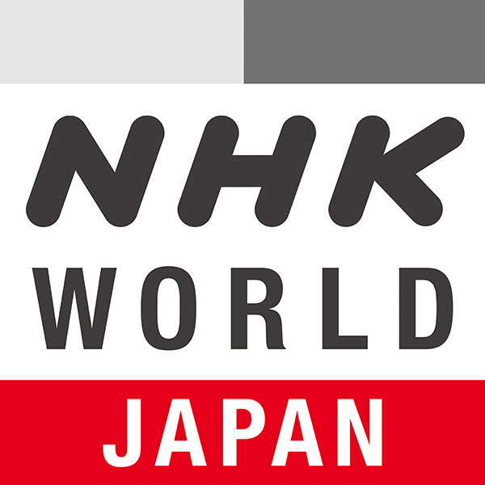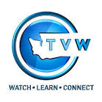

KBTC- 3 (SD) provides news, public affairs, and entertainment from around the world, including Deutsche Welle, France 24, to name but a few. The channel also includes independent producers and original MHz Network productions. MHz Worldview on KBTC-3 serves as a liaison in bringing programs and understanding from around the world to Western Washington audiences.

KBTC- 4 (SD) provides coverage of state government and politics. TVW is available on the web and Comcast Cable. That leaves a large number of viewers without access. KBTC partners with TVW to provide this content over the air 24/7.

2019 LOCAL CONTENT AND SERVICE REPORT
IN THE COMMUNITY

KBTC Public Television is committed to telling local stories not told anywhere else, serving underserved and diverse audiences, and convening conversations that connect viewers with the people and ideas that shape our community.

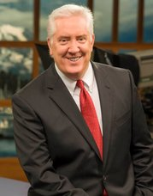

Since 2012, Tom Layson has served as KBTC’s Producer and host of Northwest Now, our weekly Friday night public affairs program. Under Tom’s leadership, viewers have come to count on interesting guests, provocative topics, and great storytelling.

Tom and his guests go beyond the headlines to provide the context people need to more fully understand the issues that affect all of us in Western Washington. Hundreds of regional and national thought leaders, policy experts and newsmakers have appeared on the program. The award winning show also covers arts & culture and includes content shot in the field as well as in-studio.

Northwest Now Highlights
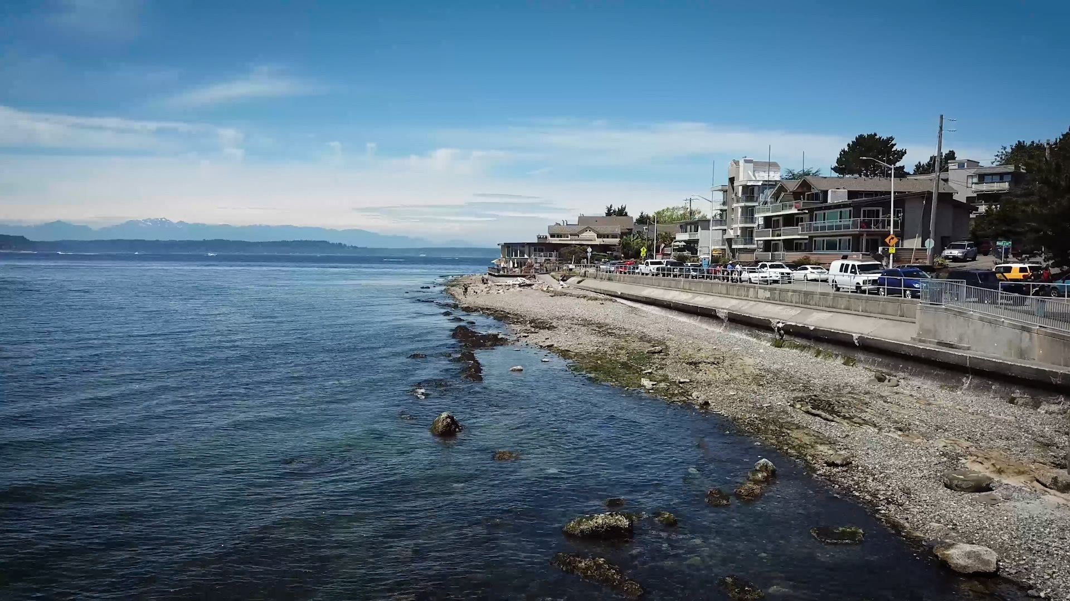
This season’s programs included an examination of the regional economy, human trafficking, police accountability, Washington's child welfare system, efforts to preserve an historical local landmark, education about women’s cardiovascular health. Tom reports in-depth on topics of particular interest to the region. Some recent special topics included Shorelines of Stone, which probed threats to the Puget Sound’s food web and the endangered species that rely on it and Earthrise, an interview with local resident Bill Anders, one of the Apollo 8 Astronauts on the anniversary of the orbit.

Northwest Now Digital First stories featured short stories on the East Side Community Center, Orca Task Force, the Northwest African American Museum and the Madras Maiden, one of only 12 still flying B-17s.

Northwest Now programs are streamed on demand on kbtc.org where viewers can also find podcast previews of upcoming programs, and watch short-form Northwest Now Digital First.

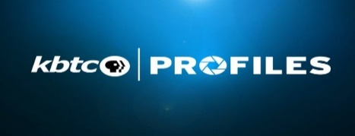
Local & Regional Content

KBTC’s on-air and online short-form series of stories about the people, places and events in and our around our Western Washington community.

2019 LOCAL CONTENT AND SERVICE REPORT
ENGAGING WITH THE COMMUNITY

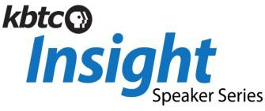
KBTC engages the community through screenings, meet-ups and educational services:
<Station logo
here>
A speaker series featuring experts from the arts, education, the environment and history sharing their insights on creativity and their field. Captured in studio in an intimate setting, the talks and presentations are streamed online at kbtc.org.

KBTC KIDS

Educates and supports youth in our community. KBTC Kids integrates PBS KIDS resources into out-of-school settings for expanded learning opportunities. The activities are offered at four elementary schools and two community sites. The activities are tailored to the location and participants.

Spring Break & Summer Break Camps

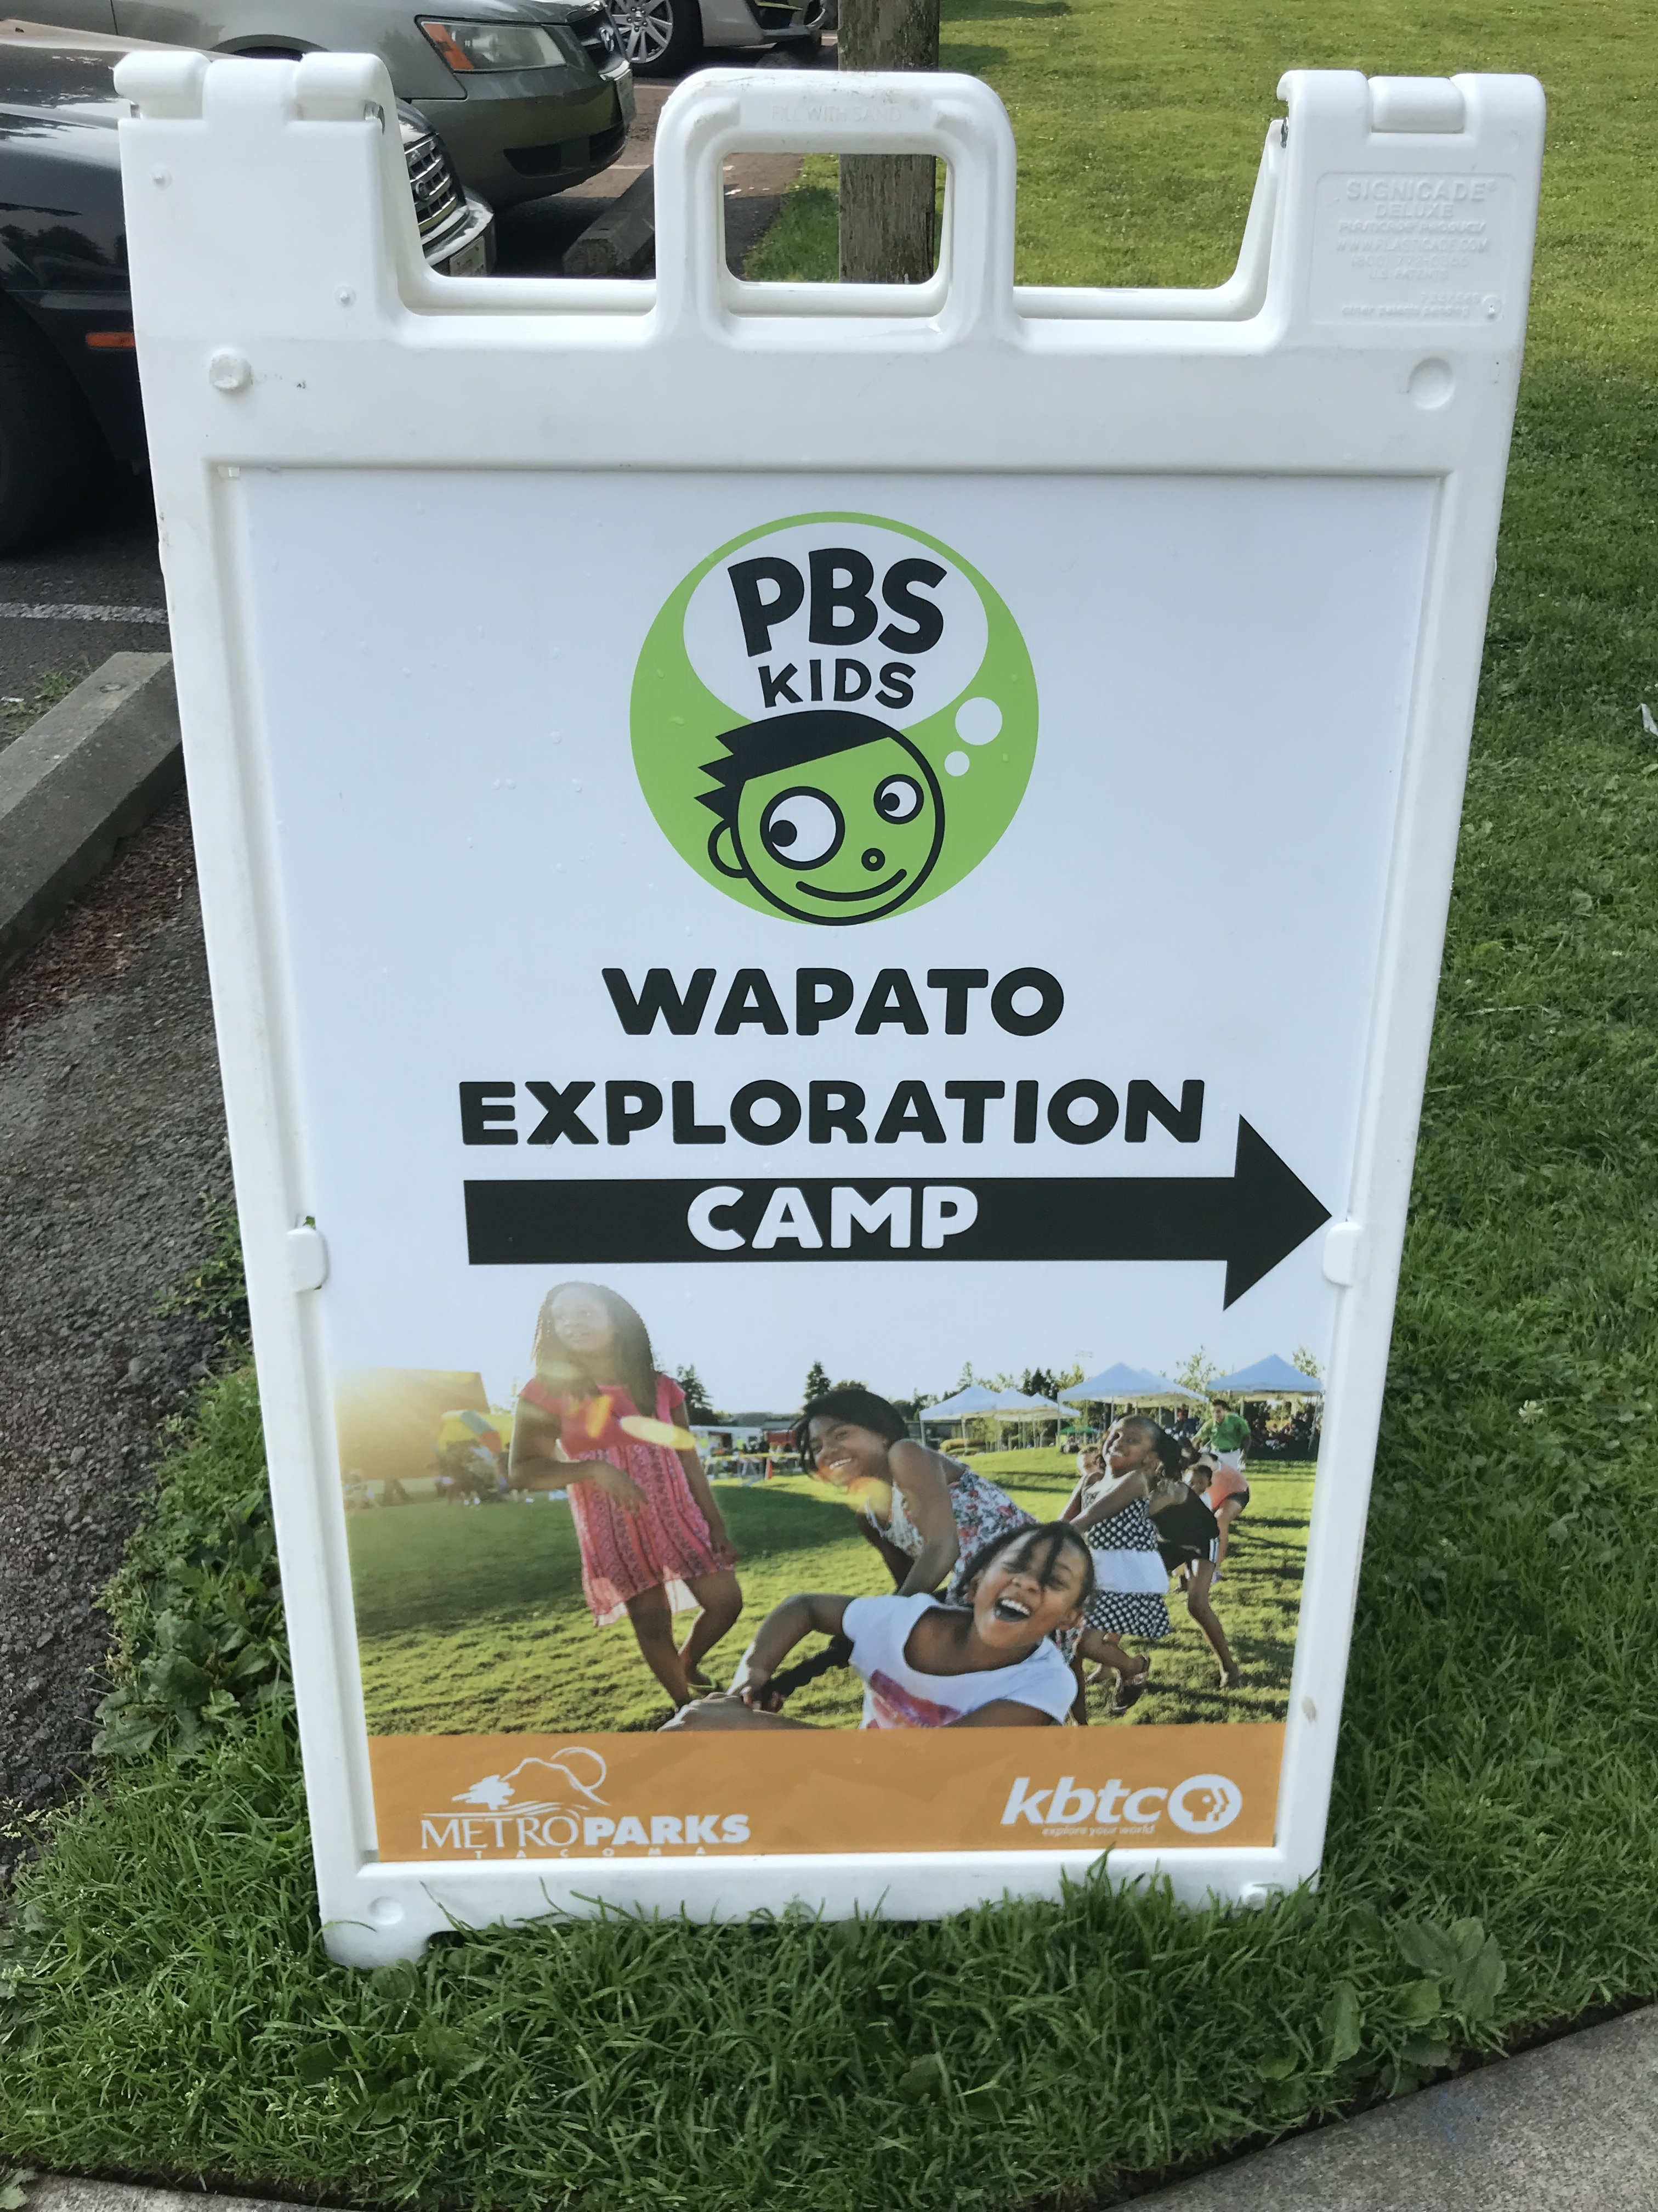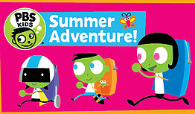

The KBTC Ready to Learn Community Collaborative for Early Learning Media (CC-ELM) partners with several agencies to reach students and families to provide services and events.

After School Programs including computer labs, STEM based activities, reading, homework help and snacks in several locations including Tacoma Housing Authority locations and elementary schools.

Family Programs, including Paint Nights, Family Creative Learning Workshops and PBS Playdates.

Community partners:
Tacoma Public Schools YMCA
Tacoma Housing Authority Graduate Tacoma
United Way Pierce County Peace Lutheran Church
Puget Sound Educational Service District MetroParks Tacoma
Children’s Museum of Tacoma Pierce County Libraries
Greater Tacoma Community Foundation First 5 FUNdamentals
Bates Technical College Child Studies Tacoma Rescue Mission

2019 LOCAL CONTENT AND SERVICE REPORT
STORIES OF IMPACT

Exploring the World

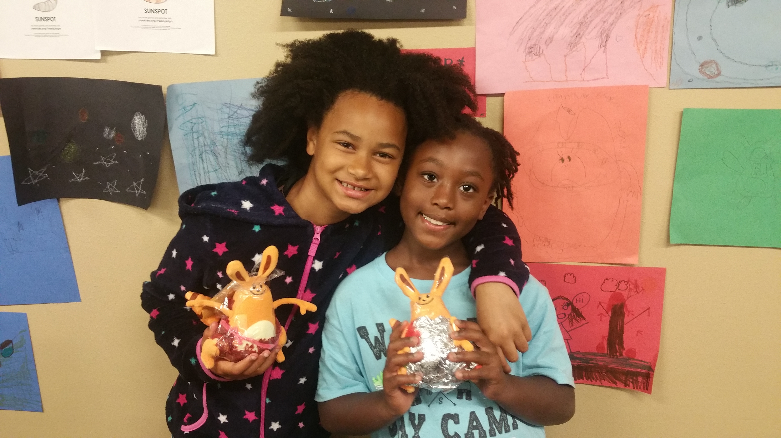
<Station logo here>

KBTC in partnership with Metro Parks Tacoma offer a month-long camp experience that includes outdoor exploration activities and hands-on science and engineering lessons featuring Ruff Ruffman and other PBS Kids shows.

Encouraging Teamwork

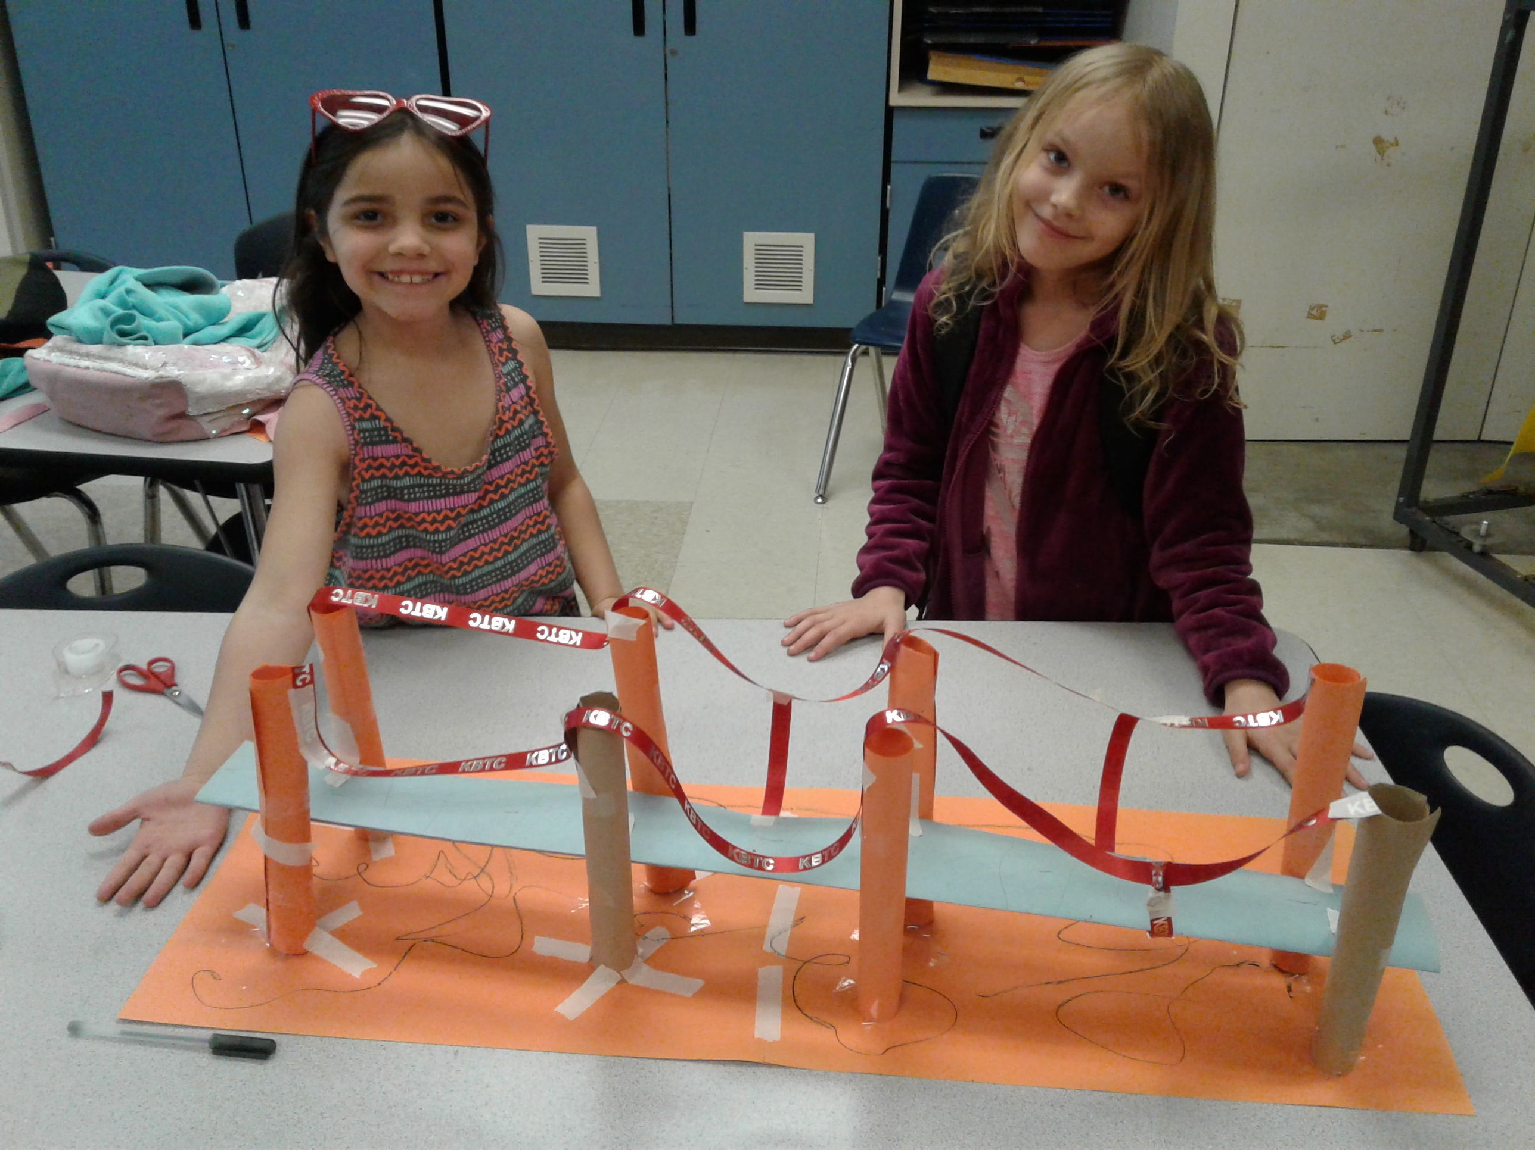

Students at Roosevelt Elementary School building a suspension bridge.

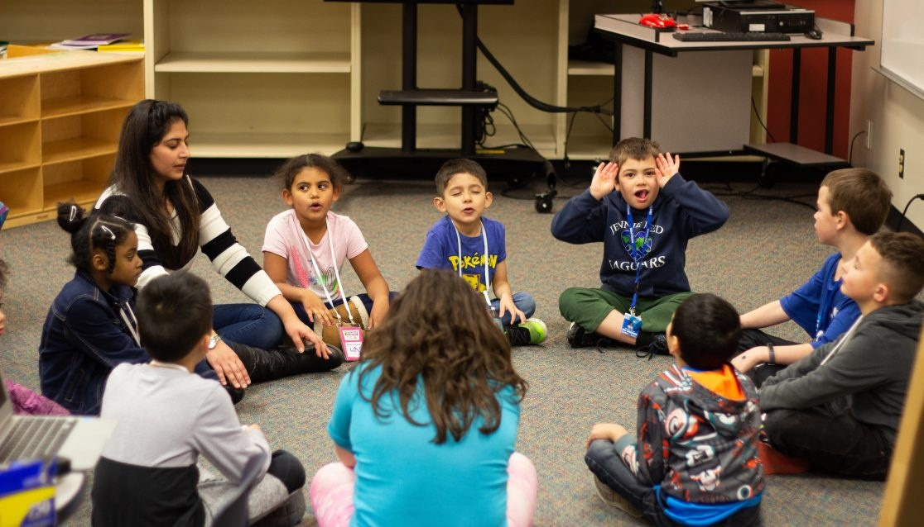
KBTC works alongside the Greater Tacoma Community Foundation with several community partners to provide a safe place for students to learn new skills, build positive relationships, and connect with their community through STEM activities and Social Emotional Learning opportunities.

2019 LOCAL CONTENT AND SERVICE REPORT
STORIES OF IMPACT

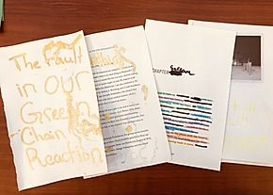
Leading the Way
Gabe’s Story
Alaina Ewing

When Gabe walked into Pacific Lutheran Church to attend the Spring Break programming, KBTC staff members were happy to see him. Gabe has attended several other KBTC programs in the past, like the Wapato Summer Camp, and staff have had the pleasure of seeing him grow over the years. As Gabe has gotten older, however, some of the PBS KIDS activities have lost their newness and excitement. While the other kids were taking part in Ready Jet Go! activities, blackout poetry and designing a neighborhood, Gabe began to wander. When the staff realized he was bored, they asked if he would like to get the group started on their Paint to Learn activity.

"I tried to explain how to mix colors," Gabe began as he sat cross-legged on the floor when the activity was over.

"I showed the kids how to make new colors by combining others. Then I showed them what negative space is and why that's important. You don't want everything to be in color because negative space helps other things stand out. I painted an orange tree and city buildings using cross-hatch," he leaned in close and whispered, "that's a kind of art technique where you use scratchy lines."

Gabe shared that he was nervous when the staff asked if he wanted to get the kids started, but he got over that feeling quickly the more he worked with the other kids.
"I just tried to think about things that would help them. I told them to think about shapes they see in the world and to start there. Then they could add onto those shapes. That seemed to help them."
Gabe didn't just get the kids started on their painting activity, he continued to lead them throughout. He explained techniques, colors, styles, and created his own art to use as an example. Gabe utilized past Ruff Ruffman and Odd Squad activities to help him teach the kids, moving him from past attendee to a role of leadership among his peers.
"Leading them was fun. I was nervous at first but I'm glad I did it and I'd do it again. Once I got started it wasn't as hard as I thought it would be. Now I know what I can do with my own art set at home."

2019 LOCAL CONTENT AND SERVICE REPORT
SUMMARY

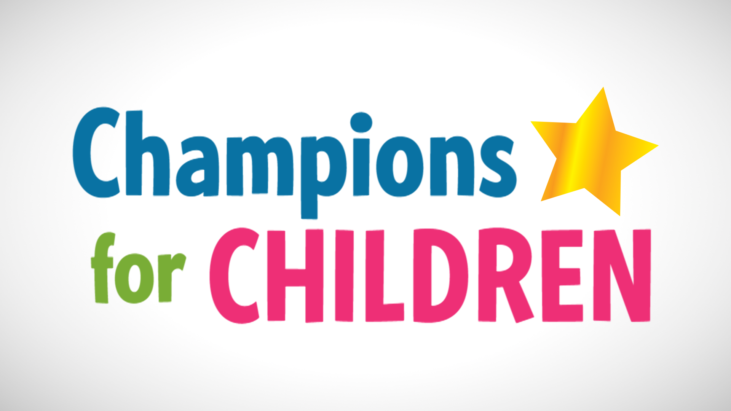

KBTC provides many different services to western Washington residents

- Giving children a chance to be successful through Ready to Learn

Spring & Summer Break Camps for children

- Convening screenings of programs to foster and encourage dialogue and celebrate diversity

- Connecting with the community through events and planned meet-ups

- Examination of local issues and concerns on Northwest Now

Celebrating the arts through storytelling

- Partnering with like-minded, mission oriented organizations

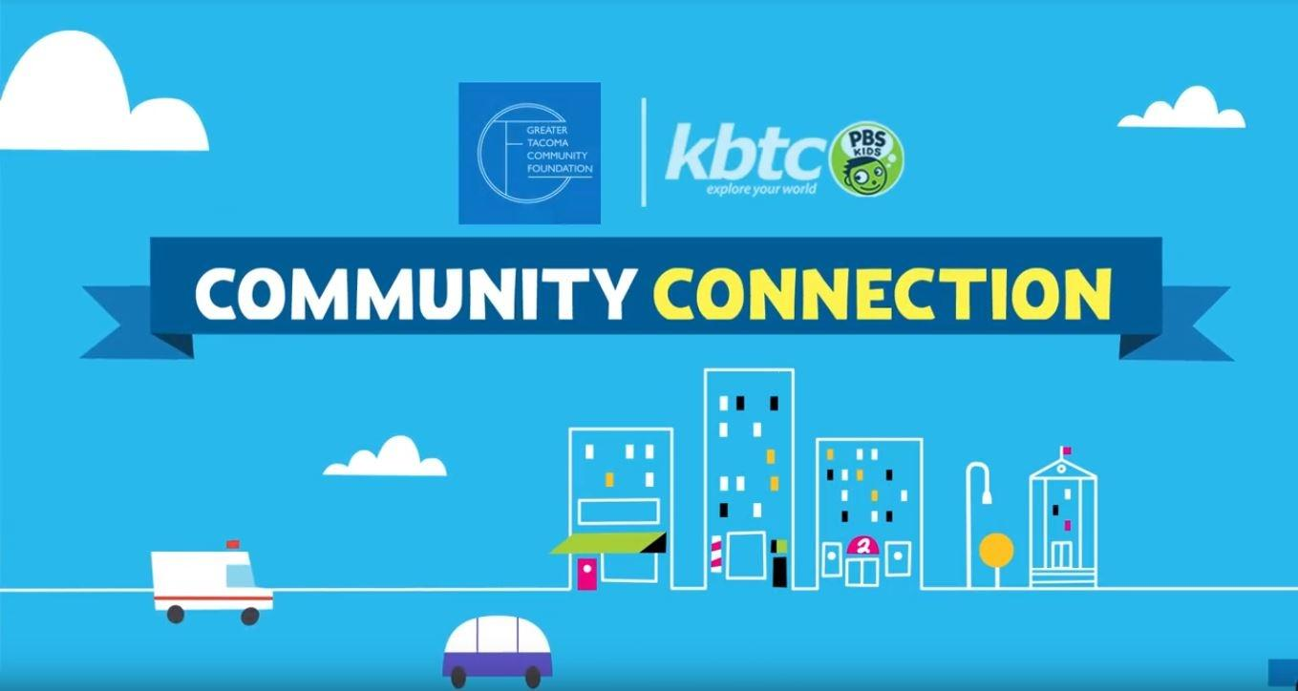

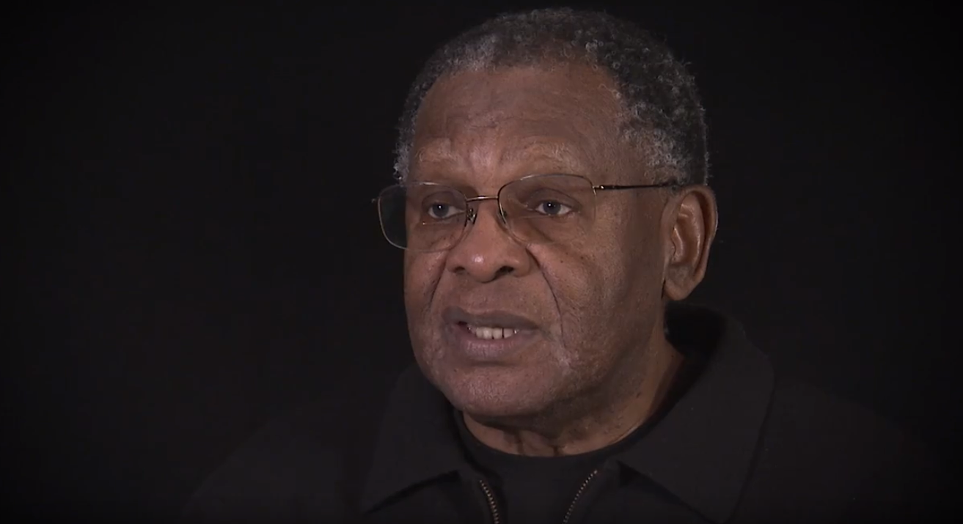

Community Leader

Lyle Quasim was the recipient of the 2019 William P. Mohler Community Impact Award

KBTC Public Television is proud to serve communities in western Washington, and our neighbors in Oregon and Canada!

KBTC’s mission is to engage viewers, communities and supporters by delivering media experiences that educate, inspire and entertain!

